400 Water Avenue, P.O. Box 527. Hillsboro, Wisconsin 54634 (608) 489-8000

January 1, 2024
LABORATORY ANNUAL NOTICE TO PROVIDERS
To: Gundersen St. Joseph’s Hospital and Clinics Clinicians

From: Sean Agger, PhD, Medical Director of Gundersen St. Joseph’s Hospital and Clinics; Keith Frye, Administrative Director, Gundersen Health System Laboratory; Candice Blaha, Gundersen St. Joseph’s Hospital and Clinics Manager of Laboratory Services.

cc: Kari Adank, Vice President, Compliance; Taryn Zubich, Director of Compliance (GLMC & MN CAH); Peter Weidenheim, Director of Compliance (WI & IA CAH).
To comply with Medicare requirements, Gundersen St. Joseph’s Hospital and Clinics Laboratory must send an annual notice to providers who use our testing services. As required, this annual notice includes the following:
Medical Necessity Requirements
Laboratory tests are reimbursed under federally funded programs if they are deemed “medically necessary” for the diagnosis and treatment of the patient. The Centers for Medicare and Medicaid Services (CMS) has developed national and local coverage decisions that identify those tests that CMS determined will be covered under the Medicare program. Coverage for these services is based on the diagnosis / sign / symptom you assign to the office visit. CMS’ National Coverage Decisions (NCDs) and Local Medical Review Policies (LMRP) can be accessed at http://www.cms.gov/medicare-coverage-database/search.aspx
Physicians may order any laboratory tests, including screening tests that they believe are appropriate for the treatment of their patients. Tests that are considered screening tests are generally not covered. Therefore, it is a requirement that a diagnosis or symptom is linked to each test ordered.
Advance Beneficiary Notice (ABN or Waiver)
Advance Beneficiary Notices are used when you believe that Medicare may not cover an ordered service. The ABN (CMS-R-131) Form, Approved OMB No. 0938-0566, is the only written notice recognized by Medicare to satisfy the requirement for alerting Part B fee-for-service beneficiaries when they may be financially liable for an item or service that Medicare will likely deny. The Notice of Denial of Medical Coverage is used when you believe that Medicare Part C (Medicare Advantage) may not cover an ordered service. Each Medicare Part C plan is required to have its own NDMC and cannot use the Medicare approved ABN. Gundersen Health System uses a Senior Preferred Notice of Denial Medical Coverage.
When an order requiring an ABN is placed, the patient should be notified, in writing, of the possibility that payment will be denied. A valid ABN or NDMC must include written estimates for the cost of services. An ABN or NDMC is never required in emergent or urgent care cases. The form provides a space to write the test(s) that are ordered and a check-off list of the reasons the claim may be denied.
This information must be completed before the patient is asked to sign. Patients cannot be asked to sign a blank or incomplete form. Patients do not need to sign the Senior Preferred Notice of Denial Medical Coverage. The patient’s name and the patient or guarantor’s signature and date of service must be on the form. The ABN or NDMC should only be used when you believe that “medical necessity” requirements may not be met. The patient must be given a copy of the ABN or NDMC form and a copy should be kept at your facility. To meet these requirements; the ABN or NDMC form prints to be filled out by the patient, the original form is scanned back in as a document after the patient signs the ABN or has been provided an SP-NDMC, and the patient receives a copy.
Panels/Profiles
Gundersen St. Joseph’s Hospital and Clinics Laboratory offers a small number of disease-oriented test groups, often referred to as profiles or panels that are found in the Current Procedural Terminology (CPT) coding manual. It should be noted that tests that make up the panels can be ordered separately. If all tests that make up a designated panel are ordered separately the panel will be billed.
This letter informs physicians that using a customized profile may result in the ordering of tests for which Medicare may deny payment.
Currently we offer the following AMA defined panels:
Lipid Panel Lipoprotein Analysis CPT 80061
Cholesterol, Total
HDL Cholesterol
Triglycerides

Electrolyte Panel CPT 80051
Carbon Dioxide
Chloride
Potassium
Sodium

Bacterial Enteric Panel CPT 87505
Salmonella spp.
Shigella spp./EIEC,
Campylobacter spp. (jejuni and coli)
Shiga toxin-producing organisms (STEC, Shigella dysenteriae).

Respiratory Infection, Multiplex (BioFire Film Array) CPT 0202U
Adenovirus Cornavirus 229E Coronavirus HKUI
Coronoavirus NL63 Coronavirus OC43 Middle East Resp. Syndrome Coronavirus
Severe Acute Resp Syndrome Coronavirus Human Metapneumovirus
Human Rhinovirus/Enterovirus Influenza A H1-2009
Influenza A H3 Influenza B Parainfluenza Virus 1
Parainfluenza Virus 2 Parainfluenza Virus 3 Parainfluenza Virus 4
Respiratory Syncytial Virus (RSV) Bordatella parapertussis (IS 1001)
Bordatella pertussis Chlamydia pneumoniae Mycoplasma pneumoniae

4Plex CPT 0241U
Covid-19 Influenza A, B RSV

INRSV CPT 87631
RSV
Influenza A, B

Blood Culture Identification Panel CPT 87150 (per organism)
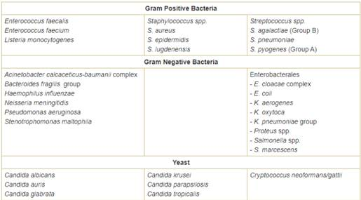
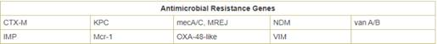

Joint Infection Panel CPT 87999
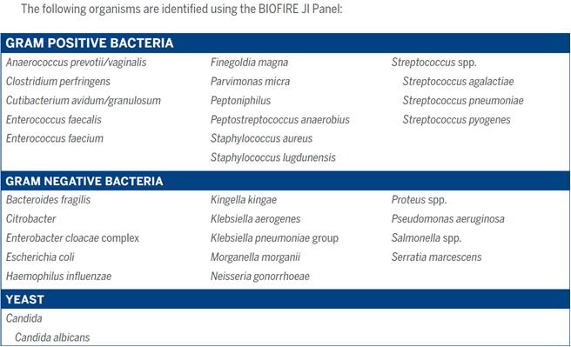

Other test groups, such as Hepatitis Panel, are offered but do not include the exact makeup of tests that CMS specifies. In these cases, individual members of the test group are billed separately, and each component of a panel must have a diagnosis linked to it. Unless all components of the panel are “medically necessary”, according to Medicare’s (NCD)-LMRP-, the claim will be denied.
The Office of Inspector General takes the position that a provider should only order those tests which the provider believes are medically necessary for each patient; therefore, all components of a customized profile must be medically necessary and will be reimbursed separately in accordance with the clinical laboratory fee schedule. A provider, who knowingly causes a false claim to be submitted by ordering a customized profile that all components are not medically necessary, may be subject to civil penalties.
Medicare Reimbursement
Critical Access Hospitals are reimbursed for laboratory services by a cost percentage. At Gundersen St. Joseph’s Hospital and Clinics all payers are charged the same, and it is our understanding that the Medicaid reimbursement amount is equal to or less than the amount of Medicare reimbursement.

CPT or HCPCS Codes
Gundersen Health System will maintain detailed, up-to-date billing codes, policies, and procedures to ensure accuracy of billing for all laboratory services. Compliance, Revenue Cycle, LIS, and Laboratory is charged with responsibility to accurately maintain all information necessary for coding and billing of laboratory services. Details can be found in RevCycl-1005 (Laboratory Coding and Chargemaster Maintenance)

https://gndrsn-gundersen.policystat.com/policy/10027089/latest/

Reflex Testing Protocols
In a limited number of predefined circumstances and based on initial test results, additional subsequent laboratory tests will be performed. These are referred to as reflex testing protocols. When performed, the reflex tests are billed to the patient. If the patient’s condition does not warrant the additional testing, providers have the option to order the initial test without the automatic reflex testing. The following is a list of additional tests that laboratory staff automatically performs after a positive initial test result:

Blood Bank:
A positive antibody screen will reflex to an antibody identification testing.
A positive antibody screen on a pre-screen order will reflex an ABO/Rh.

When a clinically significant antibody is identified and red cell products are ordered, reflex testing will include antigen typing of donor cells and a Coombs crossmatch for each red cell product.

When the DAT (Coombs) test is positive, reflex testing is based on patient history and may include an antibody eluate or auto adsorption.

For Rh-negative Rho (D) Immune Globulin candidates a fetal hemoglobin stain follows a positive fetal bleed screen.

Urinalysis:
A positive Protein, Occult Blood, Leukocytes, or Nitrites is reflexed to a microscopic examination. When the color of the urine specimen is red, amber, or green or the specimen is turbid, a microscopic exam is also reflexed. A urine culture will be reflexed if the following criteria are met: >10 WBC, >10 RBC, and Bacteria >100.

If urine Dipstick Only is ordered, the microscopic exam is not performed for positive dipstick tests.

Hematology:
A manual differential is done when instrument flagging indicates the need.

A Body Fluid or CSF Cell Count and Diff with large mononuclear cells present, reflexes to a pathologist review.

Immunology:
When Hepatitis A Total is positive the Hepatitis A IgM will be performed. When ANA is positive an ANA titer will be performed.

Microbiology:
The following positive cultures reflex antibiotic susceptibility testing:
Wound and fluid cultures growing small to large number of pathogens
CSF cultures with any growth
Positive blood cultures
Urine cultures with pathogenic growth
Respiratory cultures growing large number of pathogens
Wound, tissue, fluid or sputum cultures reflex to a gram stain.

A bone marrow culture reflexes to Bone Marrow Culture (BMC), Bone Marrow- AFB (BMA), and Bone Marrow-fungal (BMF).

A negative Strep screen reflexes to a Strep culture on patients less than 18 years old.

A positive C.diff antigen/negative C. diff toxin will reflex a C.diff PCR.

A positive Cryptococcal Antigen will reflex a Cryptococcal Antigen Titer.

A positive HPV will reflex HPV Genotype

A positive HPV reflexes HPV 16 18/45 Genotype Assay

Specimens submitted for pathology review
Surgical specimens submitted for pathology review will be processed and evaluated with the use of routine macroscopic and microscopic techniques, and, when applicable and medically necessary, special/ancillary stains or other diagnostic laboratory studies performed on the specimen. The utilization of any special/ancillary stains or other studies are at the discretion of the pathologist responsible for the diagnostic assessment and will be used to establish an accurate and complete diagnosis. Microscopic examination is, with very rare exception, required for all tissue specimens submitted, unless specifically exempted according to Gundersen Health System policy Lab-2500. If a submitting provider wishes to limit or otherwise restrict the use of special/ancillary stains or other diagnostic studies on a particular specimen submitted to the laboratory for pathologic evaluation, this request should be made in writing and should accompany the specimen upon its submission to the pathology department.
Consultants
Gundersen Health System laboratory makes the following consultants available to providers to discuss appropriate testing, test ordering, and test interpretation.
(608) 782-7300 or (800) 362-9567
Daniel Schraith MD, Extension 52701
Wayne Bottner MD, Extension 52208
Sean Agger PhD, Extension 50410
Richard Wittchow MD, Extension 52709
Gordon Zeng MD, Extension 52262
Sarah Hughes MD, Extension 52640
Christopher Cogbill MD, Extension 54612
Grzegorz Gurda MD, Extension 52107
Stefan Brettfeld DO, Extension 52820
Arick Sabin DO, Extension 52817
Stephen Bloechl MD, Extension 59645
Lacey Schrader MD, Extension 56477
Rasleen Saluja MD, Extension 50381
Janet Torkelson RN, NP, Extension 52139

