

**Laboratory Annual Notice**

Date: January 01, 2024

To: Gundersen Tri County Hospital and Clinics Medical Staff; Gundersen Tri County Hospital and Clinics Associate Staff

From: Daniel Schraith, MD, Medical Director of Laboratories; Keith Frye, Administrative Director, Laboratory; Darcy Goplin, Gundersen Tri County Hospital and Clinics Laboratory Manager

cc: Kari Adank, Vice President of Compliance; Taryn Zubich, Director of Compliance (GLMC & MN CAH); Peter Weidenheim, Director of Compliance (WI & IA CAH)

To comply with the Office of Inspector General Compliance Guidance for Laboratories, and Medicare requirements, Gundersen Tri County Hospital and Clinics Laboratory must send an annual notice to providers who use our testing services.

As required, this annual notice includes the following:

**Medical Necessity Requirements**

Laboratory tests are reimbursed under federally funded programs if they are deemed “medically necessary” for the diagnosis and treatment of the patient. The Centers for Medicare and Medicaid Services (CMS) has developed national and local coverage decisions that identify those tests that CMS determined will be covered under the Medicare program. Coverage for these services is based on the diagnosis / sign / symptom you assign to the office visit. CMS’ National Coverage Decisions (NCDs) and Local Medical Review Policies (LMRP) can be accessed at <https://www.cms.gov/medicare-coverage-database/search.aspx>.

Physicians may order any laboratory tests, including screening test that they believe are appropriate for the treatment of their patients. Tests that are considered screening tests are generally not covered. Therefore, it is a requirement that a diagnosis or symptom is linked to each test ordered.

**Advance Beneficiary Notice (ABN or Waiver)**

Advance Beneficiary Notices are used when you believe that Medicare may not cover an ordered service. ABN's (CMS-R-131) Form Approved OMB No. 0938-0566 is the only written notice recognized by Medicare to satisfy the requirement for alerting Part B fee-for-service beneficiaries when they may be financially liable for an item or service that Medicare will likely deny. The notice of Denial of Medical Coverage is used when you believe that Medicare Part C (Medicare Advantage) may not cover an ordered service. Each Medicare Part C plan is required to have their own NDMC and cannot use the Medicare approved ABN. Gundersen Health System using a Senior Preferred Notice of Denial Medical Coverage.

Before the specimen is collected, the patient should be notified, in writing, of the possibility that payment will be denied. Valid ABN or NDMC must include written estimates for the cost of services. An ABN or NDMC is never required in emergent or urgent care cases. The form provides a space to write the test(s) that are ordered and a check-off list of the reasons the claim may be denied.

This information must be completed before the patient is asked to sign the ABN. Patients cannot be asked to sign a blank or incomplete form. Patients do not need to sign the Senior Preferred Notice of Denial Medical Coverage.   The patient’s name and the patient or guarantor’s signature and date of service must be on the form. The ABN or NDMC should only be used when you believe that “medical necessity” requirements may not be met. The patient must be given a copy of the ABN or NDMC form and a copy should be kept at your facility. In order to meet these requirements; the ABN or NDMC form prints to be filled out by the patient, the original form is scanned back in as a document after the patient signs the ABN or has been provided an SP-NDMC, and the patient receives a copy.

**Panels/Profiles**

Gundersen Tri-county Hospital and Clinics Laboratory offers a small number of disease-oriented test groups, often referred to as profiles or panels that are found in CPT. It should be noted that tests that make up the panels can be ordered separately. If all tests that make up a designated panel are ordered separately the panel will be billed. This letter informs physicians that using a customized profile may result in the ordering of tests for which Medicare may deny payment.

Currently we offer the following AMA defined panels:

**Lipid Panel Lipoprotein Analysis CPT 80061**

Cholesterol, Total

HDL Cholesterol

Triglycerides

**Electrolyte Panel CPT 80051**

Carbon Dioxide

Chloride

Potassium

Sodium

**Enteric Bacterial Panel CPT 87505**

Salmonella species/EIEC

Shigella species

Campylobacter species (jejuni and Coli)

Shiga toxin-producing organisms (STEC, Shigella dysenteriae)

**Respiratory infection, multiplex (BioFire Film Array) CPT 0202U**

Virus

|  |  |  |
| --- | --- | --- |
| Adenovirus | Coronavirus 229E | Coronavirus HKUl |
| Coronavirus NL63 | Coronavirus OC43 | Middle East Respiratory Syndrome Coronavirus |
| Severe Acute Respiratory Syndrome Coronavirus | Human Metapneumovirus | Human Rhinovirus/ Enterovirus |
| Influenza A H1-2009 | Influenza A H3 | Influenza B |
| Parainfluenza Virus 1 | Paramfhmeza Virus 2 | Parainfluenza Vims 3 |
| Parainfluenza Vims 4 | Respiratory Syncytial Vims |  |

Bacteria

|  |  |
| --- | --- |
| Bordetella parapertussis (IS 1001) | Bordetella pertussis (ptxP) |
| Chlamydia pneumoniae | Mycoplasma pneumoniae |

**4Plex CPT 0241U**

Covid19

Influenza A, B

RSV

**INRSV CPT 87631**

RSV

Influenza A, B

**Blood Culture Identification Panel CPT 87150 per organism**

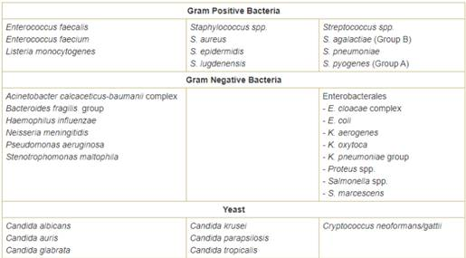



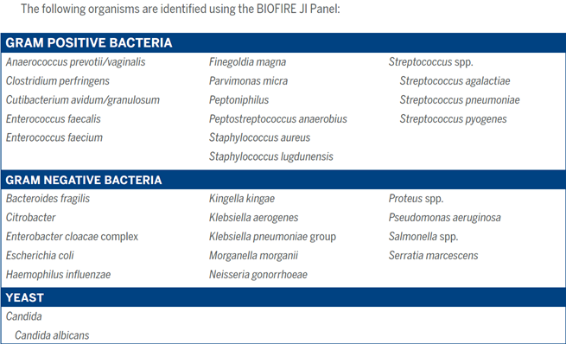



Other test groups, such as Hepatitis Panel, are offered but do not include the exact makeup of tests that CMS specifies. In these cases, individual members of the test group are billed separately, and each component of a panel must have a diagnosis linked to it. Unless all components of the panel are “medically necessary”, according to Medicare’s (NCD)-LMRP-, the claim will be denied.

The Office of Inspector General takes the position that a provider should only order those tests which the provider believes are medically necessary for each patient; therefore, all components of a customized profile must be medically necessary and will be reimbursed separately in accordance with the clinical laboratory fee schedule. A provider, who knowingly causes a false claim to be submitted by ordering a customized profile that all components are not medically necessary, may be subject to civil penalties.

**Medicare Reimbursement Fee Schedule**

Critical Access Hospitals are reimbursed for laboratory services by a cost percentage. At Gundersen Tri-County Hospital and Clinics; all payers are charged the same, and it is our understanding that the Medicaid reimbursement amount is equal to or less than the amount of Medicare reimbursement.

**CPT or HCPCS Codes**

|  |  |  |  |
| --- | --- | --- | --- |
| |  |  | | --- | --- | | Gundersen Health System will maintain detailed, up-to-date billing codes, policies and procedures to ensure accuracy of billing for all laboratory services. Compliance, Revenue Cycle, LIS and Laboratory is charged with responsibility to accurately maintain all information necessary for coding and billing of laboratory services.  Details can be found in RevCycl-1005 (Laboratory Coding and Chargemaster Maintenance) |  | |  |

**<https://gndrsn-gundersen.policystat.com/policy/10027089/latest/>**

**Reflex Testing Protocols**

In a limited number of predefined circumstances and based on initial test results, additional subsequent laboratory tests will be performed. These are referred to as reflex testing protocols. When performed, the reflex tests are billed to the patient. If the patient’s condition does not warrant the additional testing, providers have the option to order the initial test without the automatic reflex testing. Following is a list of additional tests that laboratory staff automatically performs after a positive initial test result:

**Blood Bank**:

A positive antibody screen will reflex to an antibody identification testing.

A positive antibody screen on a pre-screen order will reflex an ABO/Rh.

When a clinically significant antibody is identified and red cell products are ordered, reflex testing will include antigen typing of donor cells and a Coombs crossmatch for each red cell product.

When the DAT (Coombs) test is positive, reflex testing is based on patient history and may include an antibody eluate or auto adsorption.

For Rh-negative Rho (D) Immune Globulin candidates a fetal hemoglobin stain follows a positive fetal bleed screen.

**Urinalysis**:

A positive Protein, Occult Blood, Leukocytes, or Nitrites is reflexed to a microscopic examination. When the color of the urine specimen is red, amber, or green or the specimen is turbid, a microscopic exam is also reflexed. If urine Dipstick Only is ordered, the microscopic exam is not performed for positive dipstick tests.

**Hematology:**

A manual differential is done when instrument flagging indicates the need.

A Body Fluid or CSF Cell Count and Diff with large mononuclear cells present reflexes to a pathologist review.

**Immunology:**

When Hepatitis A Total is positive the Hepatitis A IgM will be performed. When ANA is positive an ANA titer will be performed.

**Microbiology:**

The following positive cultures reflex antibiotic susceptibility testing:

Wound and fluid cultures growing small to large number of pathogens, a CSF culture with any growth, positive blood culture, urine culture with pathogenic growth and respiratory cultures growing large number of pathogens.

Wound, tissue, fluid, or sputum culture reflexes a gram stain.

Bone marrow cultures include a Bone Marrow Culture (BMC), Bone Marrow - AFB (BMA), and Bone Marrow - Fungal (BMF)

A negative Strep antigen screen reflexes to a Strep culture if the patient is less than 18 years old.

Specimens with a positive toxin, negative antigen are considered invalid and must be sent out for PCR. All antigen positive, toxin negative specimens will reflex C. difficile toxin testing by PCR.

A positive Cryptococcal Antigen will reflex a Cryptococcal Antigen Titer.

Any positive HPV reflexes HPV 16 18/45 Genotype Assay

Specimens submitted for pathology review

Surgical specimens submitted for pathology review will be processed and evaluated with the use of routine macroscopic and microscopic techniques, and, when applicable and medically necessary, special/ancillary stains or other diagnostic laboratory studies performed on the specimen. The utilization of any special/ancillary stains or other diagnostic studies are at the discretion of the pathologist responsible for the diagnostic assessment and will be used in an effort to establish an accurate and complete diagnosis. Microscopic examination is with very rare exception required for all tissue specimens submitted, unless specifically exempted according to Gundersen Health System policy Lab-2500. If a submitting provider wishes to limit or otherwise restrict the use of special/ancillary stains or other diagnostic studies on a particular specimen submitted to the laboratory for pathologic evaluation, this request should be made in writing and should accompany the specimen upon its submission to the pathology department.

**Consultants**

Gundersen Health System laboratory makes the following consultants available to Gundersen Tri-County Hospital and Clinics providers to discuss appropriate testing, test ordering, and test interpretation:

(608) 782-7300 or (800) 362-9567

Daniel Schraith MD, Extension 52701

Wayne Bottner MD, Extension 52208

Sean Agger PhD, Extension 50410

Richard Wittchow MD, Extension 52709

Gordon Zeng MD, Extension 52262

Sarah Hughes MD, Extension 52640

Grzegorz Gurda MD, Extension 52107

Christopher Cogbill MD, Extension 54612

Stephan Brettfeld DO, Extension 52820

Arick Sabin DO, Extension 52817

Stephen Bloechl MD, Extension 59645

Lacey Schrader MD, Extension 56477

Rasleen Saluja MD, Extension 50381

Janet Torkelson, RN NP, Extension 52139