NASOPHARYNGEAL SWABS
COLLECTION INSTRUCTIONS
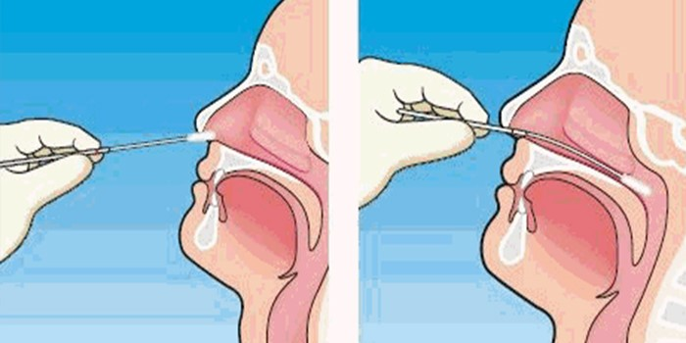
- Swabs may be obtained from SMH Laboratory by Courier Supply Request Form or by calling the hospital Laboratory.
- Explain that patient will experience a tickling sensation (similar to having a feather inserted in the nose). When the swab reaches the back of the nose, the patient may experience a desire to cough and/or may experience watery eyes.
- Have patient tilt head backwards until nasal passage openings are in a horizontal orientation, parallel to floor (sniff position).
- Remove cap from tube -save this tube to put swab into after specimen collection.
- Insert swab into one nostril. Gently pass the swab through the nostril to the posterior nasopharynx. Do not force the swab; resistance will be felt when the posterior nasopharynx is reached. If obstruction is met before swab reaches posterior nasopharynx, remove swab and re-insert in other nostril.
- Rotate swab 180-360º (half to complete circle) to collect mucosal material.
- Withdraw swab quickly.
- Return swab in the tube, labeled with patient’s full name and date of birth. Store at 2-8ºC if delay in transport is expected.
All samples must be dropped off:
Pavilion Laboratory
750 Wellington Ave entrance 22
Monday- Friday 7:00am-5:30pm
Saturday- 7:00am-12:00pm
St. Mary’s Laboratory Services
(970)298-2071

