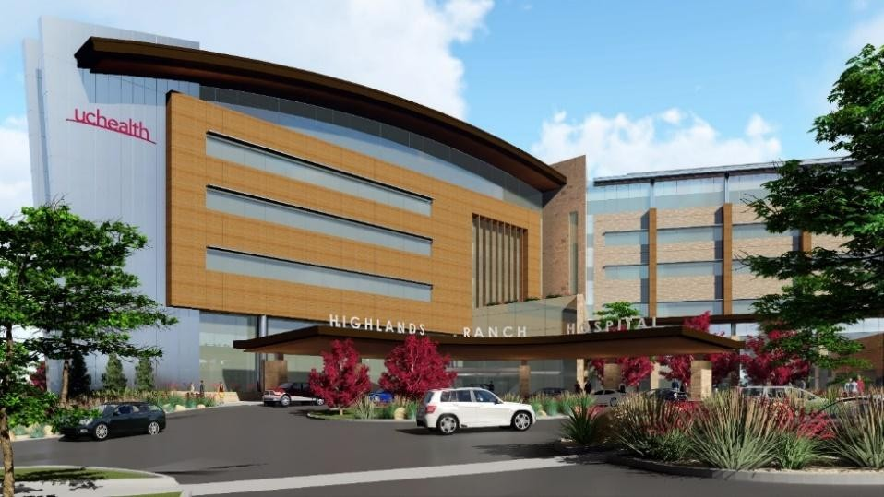

Highlands Ranch Hospital
Laboratory
Clinical and Anatomical Pathology

FY27

Laboratory Services - Clinical and Anatomical Pathology
Scope of Services
2026-2027 (FY27) Updated 7/2026
 |  | Scope of Services | Transfusion Services |  | Care  Team/Staffing  Model | Department  Standards/ Practice  Guidelines | QUALITY Metrics
➢  ➢  ➢  ➢  ➢  ➢  ➢  ➢  ➢  ➢  ➢  ➢  ➢  ➢  ➢  ➢  ➢  ➢  ➢  ➢  ➢  ➢ |  | Laboratory Services  Clinical Laboratory testing Inpatient and outpatient phlebotomy/specimen collection services  Surgical/Anatomic Pathology  Services  Clinic Support services  Clinical Pathology (CP) departments  Transfusion Services  Phlebotomy  Specimen Processing/Send-out testing to reference labs  Blood gas analysis  Chemistry  Hematology  Urinalysis  Microbiology (limited service) Molecular diagnostics (limited services)  Therapeutic drug monitoring (limited service)  Toxicology (limited service)  Clinical pathology consultation Point of Care Testing (POCT)  oversight  Anatomic Pathology (AP) departments  Surgical Pathology  Frozen Sections  Cytology  Histology/Immunohistochemistry Send-out testing to reference labs  Patient population | Products available from Transfusion Services:  - Leukoreduced Red Blood Cells  (AS-3)  - Fresh Frozen Plasma – 24-hour outdate  - Platelets- apheresis, pre-storage leukocyte reduced  - Cryoprecipitate, Pooled  - Pediatric aliquots (red cell, FFP, Cryoprecipitate, Platelets)  - Irradiated cellular products  Services provided by  Transfusion Services  - ABO/Rh typing  - Screening for unexpected antibodies  - Compatibility testing  - Antibody identification  - Direct Antiglobulin Test  - Antigen typing*  - Fetal Maternal Hemorrhage Screen Test  - Kleihauer-Betke (Fetal Maternal Hemorrhage Study)  - Antibody Titer*  * Not all antigens immediately available at HRH | •  •  •  •  •  •  •  •  •  •  •  •  •  •  ➢  ➢ | Care Team  Lab Medical Director  (CU Medicine)  AP Department  Director (CU  Medicine)  Pathologists’ (CU Medicine) Pathologists’ Assistants  Lab Leadership  (Director, Managers,  Supervisors, Leads)  Lab Quality  Coordinator  Medical Laboratory  Scientists (MLS)  Cytotechnologist  Histotechnologists  Gross Technicians  Lab Processing  Specialists (LPS)  Clinical Lab  Technicians (CLT)  Phlebotomists (PBT) Registered Nurses  Staffing Model  A Pathologist is on site at minimum  8am-4pm M-F  A Pathologist is on call 24/7 when not onsite.  Inpatient Clinical laboratory follows a | Regulatory  The laboratories operate within the regulatory requirements and/or accreditation standards  of the following organizations:  - CMS, Clinical  Laboratory  Improvement Act  (CLIA)  - College of American Pathologist (CAP)  - The Joint Commission  - Food and Drug Administration (FDA)  Departmental policies, processes and procedures are developed based on needs revealed by patient demographics, advances in the industry, changes in regulations, inspection reports, and deficiencies or inadequacies identified in current processes. Audits and systems checks are in place or are being developed as a means to evaluate and modify current processes. A standardized process is in place for the | to:  •  •  •  •  •  •  •  •  • | Metrics  Include but not limited  Patient  Experience  Critical call turnaround time Stat testing turnaround time Blood culture contamination Frozen Section turnaround time Non-concordant  Surgical Pathology discrepancies Transfusion reactions FDA reportable  Transfusion  Service events  Workload metrics
➢  ➢  ➢  ➢  ➢  ➢  ➢  ➢  ➢  ➢  ➢ | The laboratory serves all patient populations seen by Highlands Ranch Hospital, UCHealth  Cancer Center, and surrounding outpatient clinics.  o Test result reference ranges are age, sex appropriate when applicable.  Hours of Operation:  Inpatient Lab  24 hours a day 7 days a week  Outpatient Lab  0630-1700  Monday-Friday  Closed on weekends and observed holidays  Pathology/Histology/Cytology  0800-1600  Monday – Friday  Closed weekends and observed holidays unless a need arises.  Pathologist on call 24/7  Security  Badge access for staff |  |  | 24/7 patient care delivery model. Minimum staffing: 2 MLS (3 MLS  dayshift/evening shift M-F); 1 MLS designated as Charge Tech when no leadership is onsite.  1 PBT (2 PBT  dayshift/Evening shift  M-F)  Outpatient laboratory  - Minimum staffing of 1 PBT (4 PBT during normal operating hours)  Anatomic Pathology  - Histotechnologist M-F 8am-4pm.  - Pathology support M-F 8-4pm.  Minimum: At least 1 of the following titles:  Cytotechnologist Pathologists’  Assistant  Histotechnologist  CLT  LPT Specialist  - Embedded Clinic Phlebotomy – hours based on clinic  - Assignments are based on anticipated workload, and experience level of those on duty.  - Staffing needs are assessed throughout each shift. |  | implementation of new  policies and procedures.

