Kidney Biopsy Collection

Purpose
To establish procedure relative to kidney biopsy collection.

Materials
- Kidney biopsy kit
- Epic
- Printer

Procedure
- Collection of 3 separate cores is preferred.
- Immediately upon collection place tissue cores in saline solution on a petri dish.
- Use a dissection scope to examine the core(s) for blood filled glomeruli.
- If three cores are obtained place one core in each fixative provided in the kit.
- If two cores are obtained they may be divided using an alcohol cleaned razor blade as follows:
  - 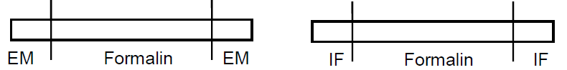
  - Cut 2mm fragments from each end of the core and submit in the appropriate fixative.
  - Place the remainder of the cores in formalin for routine processing.
- If one core is obtained it may be divided using an alcohol cleaned razor blade as follows:
  - 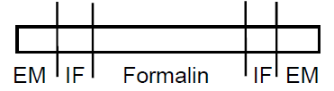
  - Cut 1-2mm fragments from each end of the core and submit in the glutaraldehyde.
  - Cut 1-2mm fragments from the new ends of the core and submit in Zeus fixative.
  - Place the remainder of the cores in formalin for routine processing.
- Three different modalities require three different fixatives:
  - Light microscopy: 10% Neutral Buffered Formalin (purple label)
  - Electron microscopy: Glutaraldehyde (green label)
  - Immunofluorescence: Zeus or Michel’s (yellow label)
    - Tissue placed in formalin first cannot be tested for Immunofluorescence and should not be transferred to Zeus or Michel’s medium.
- Kidney biopsy kits can be requested from the histology lab.

Procedure Notes
- If stat or rush results are required, the clinician must speak directly with the pathologist and provide history and contact information.
- Do not crush tissue with instruments
- If specimen floats in fixative, it is likely just adipose tissue and not renal parenchyma.
- Time of collection to receipt in pathology lab should not be greater than two hours.
- Container and requisition should be labeled with two patient identifiers, the location of biopsy, collection time and test required.

