Blood Product Tip Sheet
Blood Return Times - from the time a unit leaves the Blood Bank:
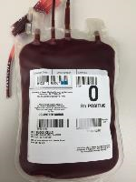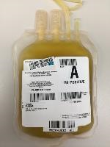
Red Blood Cells – 20 minutes
Thawed Plasma –
20 minutes
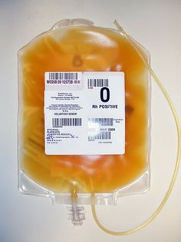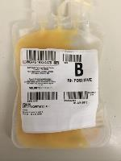
Thawed Cryoprecipitate – No limit, product expires in 6 hours
Platelets –
60 minutes
Transfusion Guidelines per Lippincott:
- Ensure that the transfusion is started within the facility-designated time of removal from transfusion services (20 minutes).

- Administer as the patient can tolerate, usually over 1½ to 2 hours, but complete the transfusion within 4 hours.

- Critical note: If there is an unexpected significant delay once blood product is picked up/sent up and the transfusion cannot be completed within 4 hours, return the unit to blood bank immediately.
Temperature Monitoring:
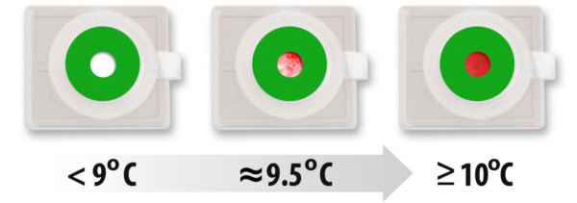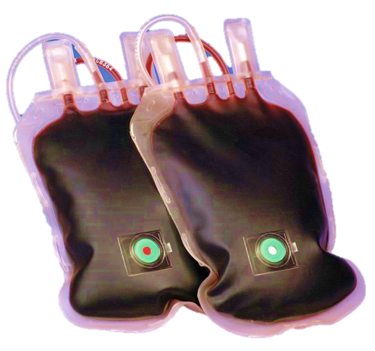
Temperature reading devices: Blood stored in coolers outside of the blood bank is monitored using a temperature indicator on each red blood cell unit.
- White/Speckled – OK to use
- Red – Call the Blood Bank

