**CHEMISTRY**

|  |  |  |  |  |  |
| --- | --- | --- | --- | --- | --- |
| **Greiner Green Top Minicollect Tube (max fill 0.8mL)**  **or** | | **Tuberculin ABG Syringe w/ Balanced Heparin**  **or**  **Heparinized Radiometer Capillary Tube** |  | **BD Red Top Vacutainer, Clot Activator NO GEL**  **or**    **BD Microtainer – red NO GEL** | |
| **Lab Test** | **Volume** | **Lab Test** | **Volume** | **Lab Test** | **Volume** |
| **Neonatal Bilirubin Total**  **Neonatal Bilirubin Panel**  NBIL, BU, BC  **Electrolyte Panel**  NA, K, CL, ECO2  **Neonatal CMP**  NA, K, CL, ECO2, GLU, BUN, CREA, CA, TP, ALB, TBIL, BU, BC, ALP, AST, ALT  **Neonatal HFP**  TP, ALP, TBIL, BU, BC, ALP, AST, ALT  **Neonatal TPN BMP**  NA, K, CL, ECO2, GLU, BUN, CREA, CA, BU, BC, TRIG, PHOS, MG  **Neonatal TPN CMP**  NA, K, CL, ECO2, GLU, BUN, CREA, CA, TP, ALB, TBIL, BU, BC, ALP, AST, ALT, TRIG, PHOS, MG  **TSH**  **Gentamicin** | 0.3 mL  **BD Microtainer – LiHep**  **(max fill 0.6mL)**  0.3 mL  0.4 mL  0.8 mL  (requires **2** BD Microtainers)  0.6 mL  0.8 mL  (requires **2** BD Microtainers)  0.8 mL  (requires 2 BD Microtainers)  0.6 mL  0.3 mL | **Blood Gas, Ionized Calcium, Whole Blood Glucose, Lactate, Whole Blood Electrolytes**  **(K, Na, Cl)**  **Whole Blood Glucose**  **Lactate** | 0.3 mL syringe  1 full capillary tube  60% full / 7 cm  capillary tube | **Free T4**  **Vancomycin**  **Vitamin D, 25-hydroxy**  **Caffeine**  (send-out)  **Cortisol**  (send-out)  **Insulin-Like Growth Factor**  (send-out) | 0.5 mL  0.5 mL  0.6 mL  1.0 mL  0.5 mL  1.0 mL |
| **MIX 10 TIMES BY INVERSION** | | **NO BUBBLES** | |

**HEMATOLOGY & COAGULATION**

|  |  |  |  |
| --- | --- | --- | --- |
| **BD Lavender Top Microtainer - EDTA** | |  | Go to fullsize image  **BD Blue Top 1.8 mL Draw-Size** |
| **Lab Test** | **Volume** | **Lab Test** | **Volume** |
| **CBC, Differential, Reticulocytes, Platelet Count**  **Neonatal Evaluation**  **Type & Screen**  Direct & Indirect Coombs  - must have two initials on the label  - if the baby is to be transfused we also require either another draw or cord blood for the retype  **Parvovirus PCR**  **CMV PCR**  **HIV PCR**  (1.0 mL acceptable, but decreases sensitivity)  **Toxoplasma gondii PCR**  **G6P**  **CMV Quant** | * 1. mL   0.8 mL  1.0 mL   1. mL 2. mL   1.0 mL  1.5 mL  0.5 mL | Any combination of the following:  **Prothrombin Time**  **PTT**  **D-Dimer**  **Fibrinogen** | 1.8 mL  **BD**  **Red Top Vacutainer,**  **Clot Activator**  **NO GEL**  **Fill to clear line on tube. Do not overfill or under fill.** |
| **MIX 10 TIMES BY INVERSION TO PREVENT CLOTTING** | | | |

**Call the laboratory for questions regarding minimum collection volumes for other tests not listed here.**

**FILL & COLLECTION INSTRUCTIONS**

**Greiner MiniCollect Green Tops with Gel – How to Use:**

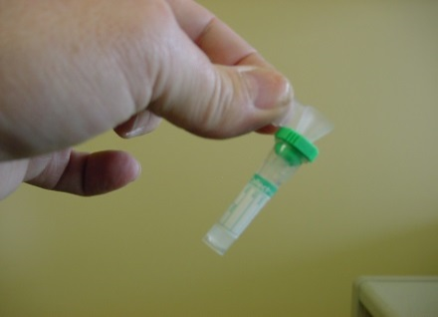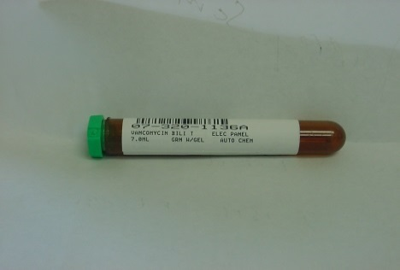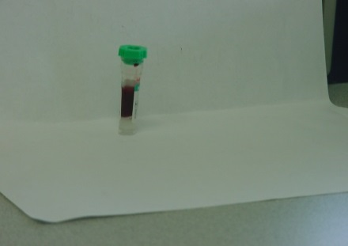

Make sure that the zebra label is placed with the patient’s name close to the top of the amber tube.

Use supplied funnel or drip blood directly into MiniCollect

Submit all MiniCollect samples in the amber carrier tube. This will provide optimal turnaround times.

**Visual Fill Guide:**

|  |  |  |
| --- | --- | --- |
| **Chemistry** | **Hematology, Blood Bank, and Virology** | **Whole Blood Capillary Tube** |
| 0.8 mL  0.9 mL  0.65 mL  0.5 mL | 0.5 mL  0.8 mL | **TO PREVENT CLOTS**  Insert the metal mixing flea and mix sample by 5 slow inversions of tube. You will feel the metal mixing flea "thump" on each end of the capillary tube as you mix. |

**ORDERING QUICK GUIDE**

**Common Neonatal Test Codes:**

|  |  |
| --- | --- |
| Neonatal Bilirubin Total | **LAB7026** |
| Neonatal Bilirubin Panel | **LAB4222** |
| Electrolyte Panel | **LAB16** |
| Neonatal Complete Metabolic Panel | **LAB5051** |
| Neonatal Hepatic Function Panel | **LAB5085** |
| Neonatal TPN Basic Metabolic Panel | **LAB3790** |
| Neonatal TPN Complete Metabolic Panel | **LAB3791** |
| CBC with Differential (Manual if Auto Fails) | **LAB210** |
| Reticulocyte Count | **LAB296** |

**To order CMA and chromosome analysis use the following order:**

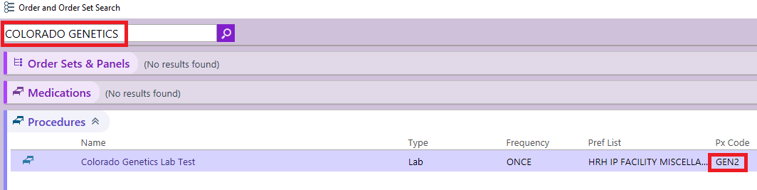

**Chromosome analysis,5-cell chromosome analysis, and FISH:** 2-3mL Na Heparin green.

**CMA**: 2mL EDTA lavender.