

BD Urine Kit Tipsheet

**Ordering**

1. 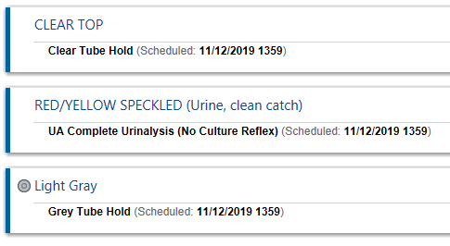Order all urine tests from “Order Sets & Panels”
2. Hold tube orders will auto-reflex. Deselect orders if no additional testing will be requested from this collection. We encourage collecting all three tubes every time.
3. From Order Inquiry, release and collect ALL 3 tubes.

**Collection**

1. Label the urine container at the patient’s bedside using two patient identifiers
2. Instruct patient not to remove yellow seal; provide clean catch instructions if appropriate.

**Urine Transfer**

1. Remove yellow seal and insert tubes firmly into lid cavity.
2. Hold tube down until adequately filled to minimum fill line.
3. Label tubes with zebra labels according to the tube type (*Speckled, Gray, and Clear*).
4. Mix all tubes 8-10 times by inversion.
5. Replace yellow seal after filling tubes.
6. Place tubes in a single biohazard bag for transport to the laboratory.

**Disposal**

1. Remove blue lid off the urine cup and place in sharps container.
2. Pour remaining urine down the toilet.
3. Dispose of urine cup in regular trash if there is no PHI on container. Use red bag trash if container has PHI.

