Welcome to Lab Gateway, UMMC - MTC’s online web test directory.
Lab Gateway contains laboratory test information to assist providers during ordering, specimen collection, as well as result interpretation.
All tests published on the Lab Gateway website are orderable at UMMC – MTC.
There are several ways to access Lab Gateway utilizing EPIC as well as the UMMC -MTC Intranet/Internet.

Option 1
From Epic, on the facility Links page (where you access CRISP). Example below is from UMMC-MTC. Each facility links page would have a link to the related Gateway.
UMMTC’s link would be “Lab Gateway – UMMC MIDTOWN”

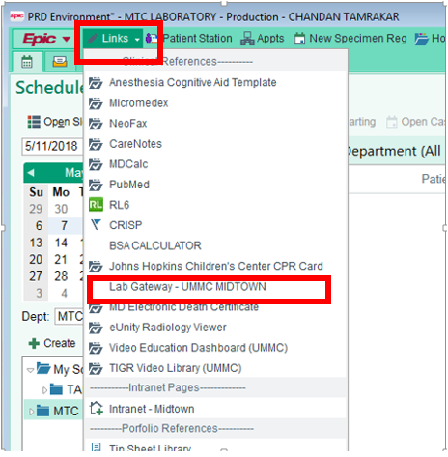

Option 2
From the intranet, on each facility’s Lab page, a link will be added. Examples of where the links may be added for each site are indicated in the red box.
UMMC-MIDTOWN 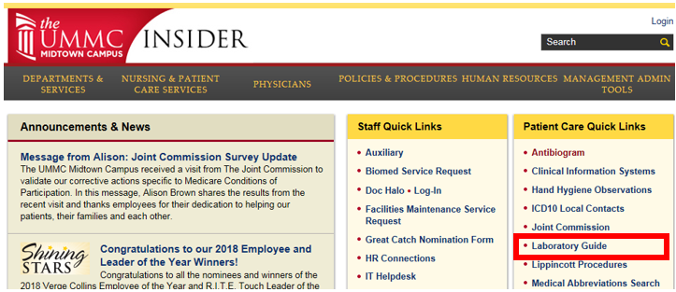
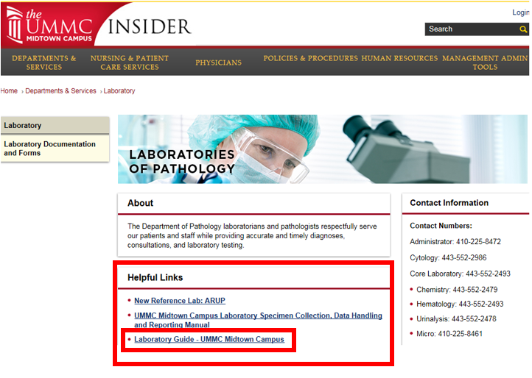

Option 3
Access will be provided from each hospital’s internet.

https://www.ummidtown.org/professionals
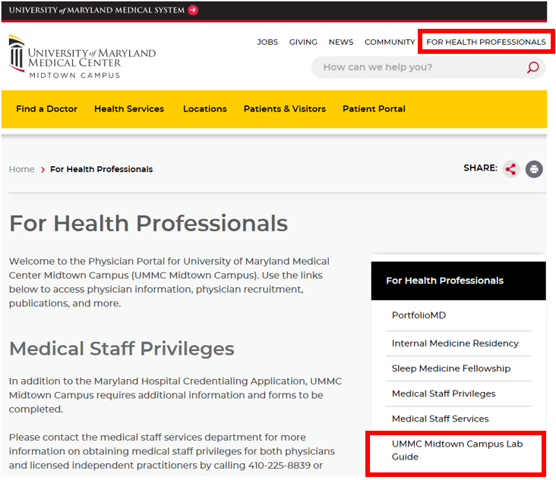

Option 4
Each site can be accessed utilizing the published URLs below. Shortcuts can also be created. URLs for ARUP Gateway websites include:
https://www.testmenu.com/ummcmidtown/

https://www.testmenu.com/UMBWMC
www.testmenu.com/UMSJMC
https://www.testmenu.com/ummc/
Extra Option
You can also access the site from your smart phones.

Welcome to https://www.testmenu.com/ummcmidtown
Search box is the portal to getting the right test information.
The Side panel contains a general grouping of test categories as well as any New () or Updated () tests.
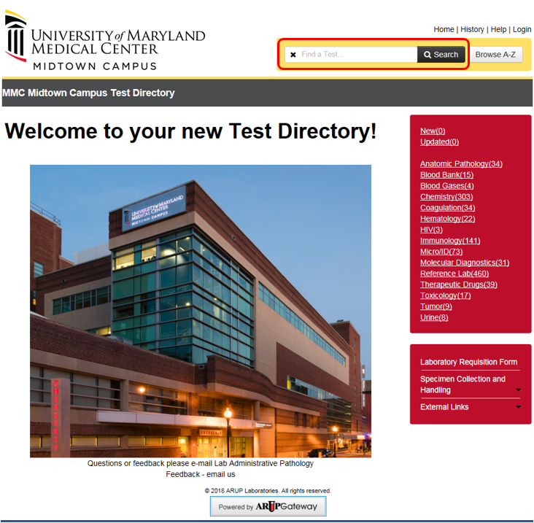
Type - CBC or Complete Blood in Search box:
Ordering tab – Ordering considerations, when the test is performed, what is the Turnaround Time, additional synonyms used for searching, Epic test code, any outside lab test code, where is the test performed.
Collection tab – Collection information, Specimen Preparation, Unacceptable Conditions, Storage/Transport Temperature, Stability (from collection to initiation), when is the test performed, where is the test performed.
Result Interpretation tab – Reference Intervals and Interpretative Data,
Administrative tab - Contains CPT code information and if the test is outsourced, the outsource test number.
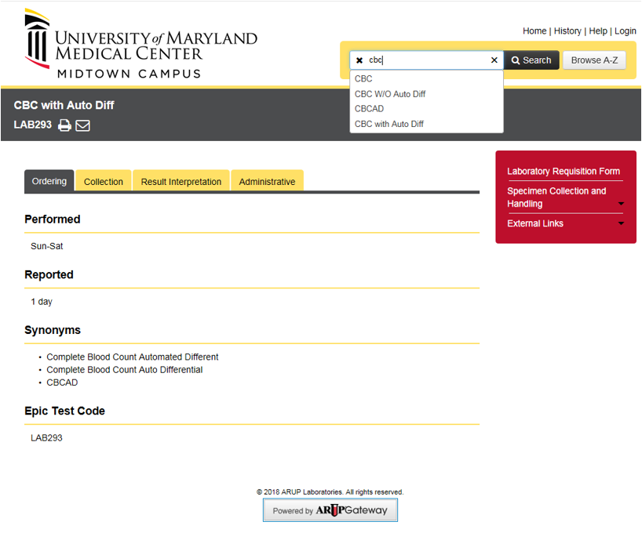

You do not need to Login to see any test directory information.
Test can be grouped into more than one category on the side right panel.

