Kev Khaws Cov Qog Aptima Rau Hauv Qhov Ncauj
1. Tshem ib feem ntawm lub pob khoom siv los ntawm daim ntaub so ntswg. Tshem daim ntaub so ntswg tawm. Tsis txhob kov lub hau mos mos lossis muab daim ntaub so ntswg tso rau hauv qab. Yog tias lub hau mos mos raug kov, daim ntaub so ntswg raug muab tso rau hauv qab, lossis daim ntaub so ntswg poob, siv cov khoom siv tshiab Aptima Multitest Swab Specimen Collection Kit, daim duab 1.
2. Tuav daim ntaub so ntswg, muab koj tus ntiv tes xoo thiab tus ntiv tes taw tso rau hauv nruab nrab ntawm lub qhov ntswg uas npog cov kab ntsuas. Tsis txhob tuav lub qhov ntswg hauv qab cov kab ntsuas, daim duab 2.
3. Ua tib zoo ntxig daim ntaub so ntswg rau hauv qhov ncauj li 1-2 ntiv tes (3-5 cm) dhau ntawm ntug qhov quav thiab maj mam tig daim ntaub so ntswg mus rau sab laug rau 5 txog 10 vib nas this. Rub daim ntaub so ntswg tawm yam tsis txhob kov daim tawv nqaij, daim duab 3.
4. Thaum tuav daim ntaub so ntswg hauv tib txhais tes, tshem lub hau ntawm lub raj. Tsis txhob nchuav cov khoom hauv lub raj. Yog tias cov khoom hauv lub raj xa dej nchuav, siv lub Aptima Multitest Swab Specimen Collection Kit tshiab, daim duab 4.
5. Tam sim ntawd muab lub swab tso rau hauv lub raj xa khoom kom cov kab ntsuas nyob rau sab saum toj ntawm lub raj, daim duab 5.
6. Ua tib zoo rhuav lub swab shaft ntawm cov kab ntsuas tawm tsam sab ntawm lub raj, daim duab 6.
7. Pov tseg sab saum toj ntawm lub swab shaft tam sim ntawd, daim duab 7.
8. Tig lub hau kom nruj rau ntawm lub raj, daim duab 8.
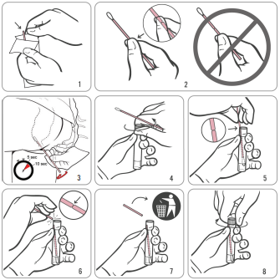
Source: Hologic IVD “Instructions for Using Aptima Multitest Swab Specimen Collection Kit for Patient-Collected Specimens”
AW-14334-001 Rev.003

