Kev Khaws Cov Qog Aptima Swab Rau Koj Tus Kheej
1. Tshem ib feem ntawm lub pob swab. Tshem cov swab. Tsis txhob kov lub hau mos lossis muab cov swab tso rau hauv qab. Yog tias lub hau mos raug kov, cov swab raug muab tso rau hauv qab, lossis cov swab poob, siv cov khoom siv tshiab Aptima Multitest Swab Specimen Collection Kit, duab 1.
2. Tuav cov swab, muab koj tus ntiv tes xoo thiab tus ntiv tes taw tso rau hauv nruab nrab ntawm tus swab uas npog cov kab qhab nia. Tsis txhob tuav tus swab hauv qab cov kab qhab nia, duab 2.
3. Ua tib zoo ntxig cov swab rau hauv caj pas kom paub tseeb tias kov cov tonsils ob sab (yog tias muaj) thiab phab ntsa pharyngeal tom qab, tom qab ntawd rub cov swab tawm yam tsis txhob kov sab hauv ntawm lub puab tsaig lossis tus nplaig, duab 3.
4. Thaum tuav cov swab hauv tib txhais tes, qhib lub hau ntawm lub raj. Tsis txhob nchuav cov khoom hauv lub raj. Yog tias cov khoom hauv lub raj xa dej nchuav, siv lub Aptima Multitest Swab Specimen Collection Kit tshiab, daim duab 4.
5. Tam sim ntawd muab lub swab tso rau hauv lub raj xa khoom kom cov kab ntsuas nyob rau sab saum toj ntawm lub raj, daim duab 5.
6. Ua tib zoo rhuav lub swab shaft ntawm cov kab ntsuas tawm tsam sab ntawm lub raj, daim duab 6.
7. Pov tseg sab saum toj ntawm lub swab shaft tam sim ntawd, daim duab 7.
8. Tig lub hau kom nruj rau ntawm lub raj, daim duab 8.
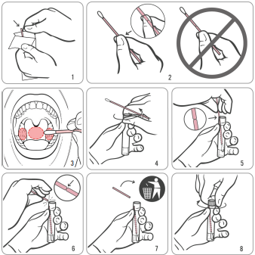
Source: Hologic IVD “Instructions for Using Aptima Multitest Swab Specimen Collection Kit for Patient-Collected Specimens”
AW-14334-001 Rev.003

