Kev Khaws Cov Qhwv Aptima Qhov Chaw Mos
1. Tshem tawm ib feem ntawm lub pob qhwv, daim duab 1. Tshem cov qhwv. Tsis txhob kov lub hau mos lossis muab cov qhwv tso rau hauv qab. Yog tias lub hau mos raug kov, cov qhwv tso rau hauv qab, lossis cov qhwv poob, siv Aptima Multitest Swab Specimen Collection Kit tshiab.
2. Tuav cov qhwv, muab koj tus ntiv tes xoo thiab tus ntiv tes taw rau hauv nruab nrab ntawm lub qhov qhwv uas npog cov kab ntsuas. Tsis txhob tuav lub qhov qhwv qis dua cov kab ntsuas, daim duab 2.
3. Ua tib zoo ntxig cov qhwv rau hauv qhov chaw mos li 2 nti (5 cm) dhau ntawm qhov chaw mos thiab maj mam tig cov qhwv mus rau sab laug li 10 txog 30 vib nas this. Xyuas kom cov qhwv kov phab ntsa ntawm qhov chaw mos kom cov dej noo nqus tau los ntawm cov qhwv thiab tom qab ntawd rub cov qhwv tawm yam tsis kov daim tawv nqaij, daim duab 3.
4. Thaum tuav cov qhwv hauv tib txhais tes, qhib lub hau ntawm lub raj. Tsis txhob nchuav cov khoom hauv lub raj. Yog tias cov khoom hauv lub raj xa dej nchuav, siv lub Aptima Multitest Swab Specimen Collection Kit tshiab, daim duab 4.
5. Tam sim ntawd muab lub swab tso rau hauv lub raj xa khoom kom cov kab ntsuas nyob rau sab saum toj ntawm lub raj, daim duab 5.
6. Ua tib zoo rhuav lub swab shaft ntawm cov kab ntsuas tawm tsam sab ntawm lub raj, daim duab 6.
7. Pov tseg sab saum toj ntawm lub swab shaft tam sim ntawd, daim duab 7.
8. Tig lub hau kom nruj rau ntawm lub raj, daim duab 8.
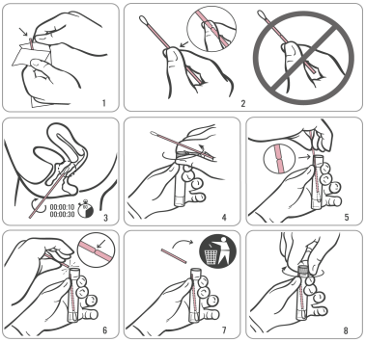
Source: Hologic IVD “Instructions for Using Aptima Multitest Swab Specimen Collection Kit for Patient-Collected Specimens”
AW-14334-001 Rev.003

