Kev Khaws Cov Qog Aptima Swab Rau Hauv Qog
1. Tshem ib feem ntawm lub pob swab. Tshem cov swab. Tsis txhob kov lub hau mos lossis muab cov swab tso rau hauv qab. Yog tias lub hau mos raug kov, cov swab raug muab tso rau hauv qab, lossis cov swab poob, siv cov khoom siv Aptima Multitest Swab Specimen Collection Kit tshiab, daim duab 1.
2. Tuav cov swab, muab koj tus ntiv tes xoo thiab tus ntiv tes taw tso rau hauv nruab nrab ntawm lub swab uas npog cov kab qhab nia. Tsis txhob tuav lub swab qis dua cov kab qhab nia, daim duab 2.
3. Saib daim duab 3 yog tias koj tau txiav daim tawv nqaij. Saib daim duab 4 yog tias koj tsis tau txiav daim tawv nqaij. Cov txiv neej uas tsis tau txiav daim tawv nqaij yuav tsum dov daim tawv nqaij ntawm lub qhov chaw mos ua ntej pib khaws. Dov cov swab mus rau sab laug ntawm lub qhov ntawm tus qau, sab nraum qhov qhib ntawm tus qau (qhov uas tso zis). Nws tsis tas yuav muab cov swab tso rau hauv qhov qhib ntawm tus qau. Nco ntsoov dov cov swab thoob plaws qhov qhib ntawm tus qau kom tau cov qauv zoo tshaj plaws. Xyuas kom cov swab tsis kov lwm qhov ntawm daim tawv nqaij.
4. Thaum koj tuav daim ntaub so ntswg hauv tib txhais tes, qhib lub hau ntawm lub raj. Tsis txhob nchuav cov khoom hauv lub raj. Yog tias cov khoom hauv lub raj nchuav, siv Aptima Multitest Swab Specimen Collection Kit tshiab, daim duab 5.
5. Tam sim ntawd muab daim ntaub so ntswg tso rau hauv lub raj thauj khoom kom cov kab ntsuas nyob rau sab saum toj ntawm lub raj, daim duab 6.
6. Ua tib zoo rhuav lub qhov ntawm daim ntaub so ntswg ntawm cov kab ntsuas tawm tsam sab ntawm lub raj, daim duab 7.
7. Pov tseg sab saum toj ntawm lub qhov ntawm daim ntaub so ntswg tam sim ntawd, daim duab 8.
8. Muab lub hau ntsia kom nruj rau ntawm lub raj, daim duab 9.
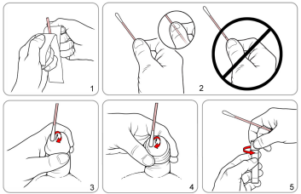
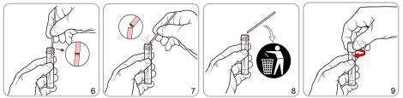
Source: Hologic IVD “Instructions for Using Aptima Multitest Swab Specimen Collection Kit for Patient-Collected Specimens”
AW-14334-001 Rev.003

