Physicians’ Newsletter
December 2022

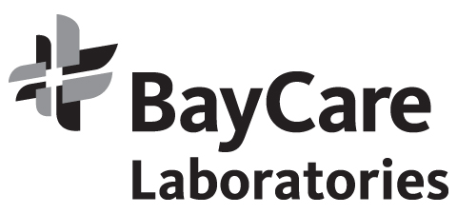

IMPORTANT: COURIER SERVICE NOTICE FOR CHRISTMAS DAY & NEW YEAR’S DAY

Due to the upcoming holidays, the BayCare Courier Service would like to notify you that regularly scheduled pickups WILL NOT occur on December 24, 25, 26 and 31 and January 1 and 2.
If your office has a regularly scheduled pickup and you have specimens to be picked up on ANY of these days, please call Courier Dispatch at (866) 453-5499 or (727) 953-9703. Thank you.

PATIENT SERVICE CENTER HOURS FOR THE HOLIDAYS

BayCare Outreach Laboratories Patient Service Centers will offer the following holiday hours for Christmas Eve and New Year’s Eve. ALL SITES will be CLOSED Christmas Day and New Year’s Day.

Normal Hours at the sites below Christmas Eve and New Year’s Eve:
- Bartow
- Dunedin
- St. Joseph’s MAB MLK
- St. Joseph’s Pedi Clinic MLK
- Trinity
CLOSING: 1pm for Christmas Eve and New Year’s Eve:
- Countryside
CLOSED: Christmas Eve and New Year’s Eve:
- Bardmoor
- Suncoast
CLOSED: 12/26 (Christmas Day observed):
- All Patient Service Centers
CLOSED: 0l/02/23 (New Year’s Day observed):
- All Patient Service Centers

NURSICS AND NEW YEAR’S DAY SERVICE

SKILLED NURSING FACILITIES – CHRISTMAS DAY & NEW YEAR’S DAY SERVICE

BayCare Outreach Laboratories WILL NOT be performing routine morning phlebotomy rounds on December 25 or January 1.
If you require a patient collection on Christmas Day or New Year’s Day, please call Lab Customer Service at (800) 324-7853 and a STAT phlebotomist will be dispatched.
Home draws will be closed on December 26 and January 2.

Customer Service: (800) 324-7853
https://baycare.org/services/laboratories

