Chlamydia trachomatis/Neisseria gonorrhoeae Collection Guide
Updated 5/26/2021

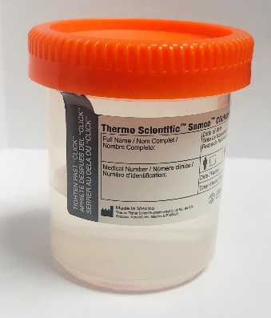
- Urine specimen collection: (not currently restricted)
  - Send raw urine to the lab promptly
  - Lab will put in correct transport media for referral testing or perform inhouse test depending on patient age

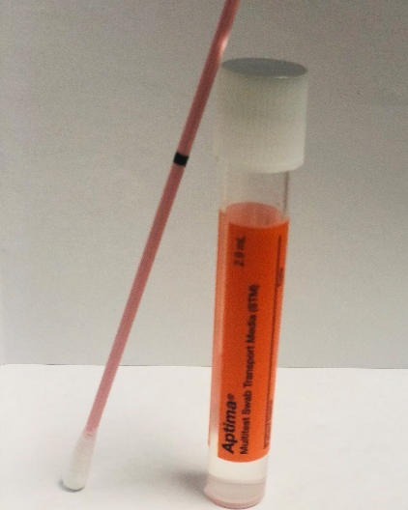
- Aptima Multi-test Swab collections, acceptable sources: (not currently restricted)
Aptima Multi-test Swab
  - Rectal
  - Throat
  - Vaginal
  - Ocular – we are now sending these to Mayo Clinic. Mayo Clinic does accept the Multi-test swab
    - Due to shortage of unisex swabs, Multi-test swab collections are now accepted. This is a change as of 1/14/2021.
    - Aptima Unisex swabs acceptable, but supplies are not as readily available

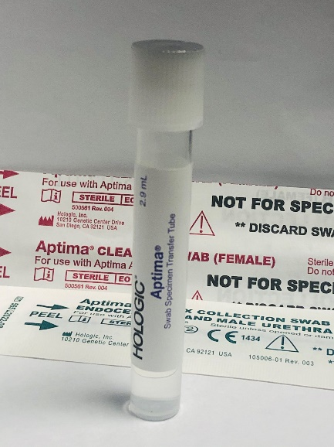
- Aptima Unisex swab collections, sources:
  - Endocervical- cannot be collected on multi-test swab
Aptima Unisex
Swab
  - Urethral- cannot be collected on multi-test swab
  - If Aptima unisex swabs are not available, consider alternative sources (vaginal instead of endocervical and urine instead of urethral).

