April 30, 2021
Re: CXCL9 Test Method/Reference Range Change

Dear Cincinnati Children’s CBDI Clinical Laboratory Clients:

A new CXCL9 method is in effect as of 5/3/2021. CXCL9 is now measured by an automated microfluidics immunoassay method.Values of CXCL9 measured with the current method generally run 5 to 10 fold higher than when measured with the previous ELISA method. The current reference range is ≤ 647pg/mL.
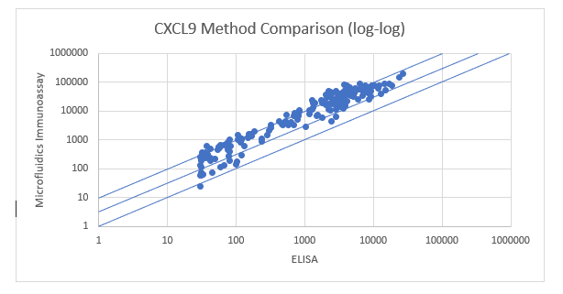
Graph showing the correlation of CXCL9 sample values obtained using the ELISA method versus the new automated microfluidics immunoassay method.

Collection Instructions:
Collection and specimen handling remain the same as with the previous method. 3mL whole blood should be collected for each test using EDTA as an anticoagulant (lavender top tube). Process and freeze separated plasma within 8 hours of collection. Freeze immediately at -20°C or lower. Ship on dry ice.
Please refer to our requisition for sample collection and shipping instructions.

Handling Conditions:
Separated plasma samples that have been frozen must be sent with enough dry ice to maintain a frozen state until received in our lab. All vials should be labeled with patient name, MRN, DOB, date of sample collection, and anticoagulant.

Please feel free to contact us with any questions you may have.
Thank you.
The CBDI Diagnostic Immunology Laboratory at Cincinnati Children's
Phone 513.636.4685 | Fax 513.636.3861 | Email: CBDILabs@cchmc.org
3333 Burnet Avenue | R2328 | Cincinnati, Ohio 45229-3039
www.cincinnatichildrens.org/DIL

