Using the Laboratory Test Directory to locate reference ranges
Click on the link below.
Pathology & Lab Services | The University of Kansas Health System
Scroll down the page. Click on the link embedded in this box:
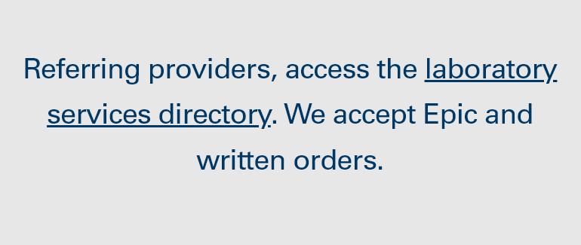
Search for the information you need using the key word, name, or right-hand toolbar options:
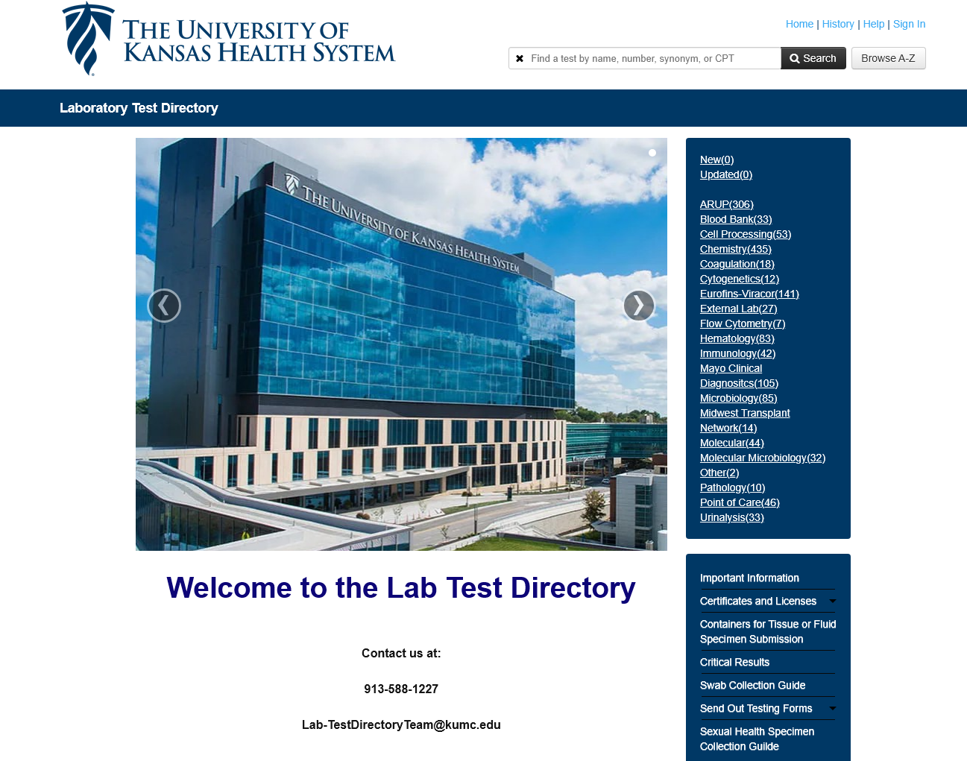

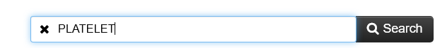

Select the test and performing lab you would like to view:
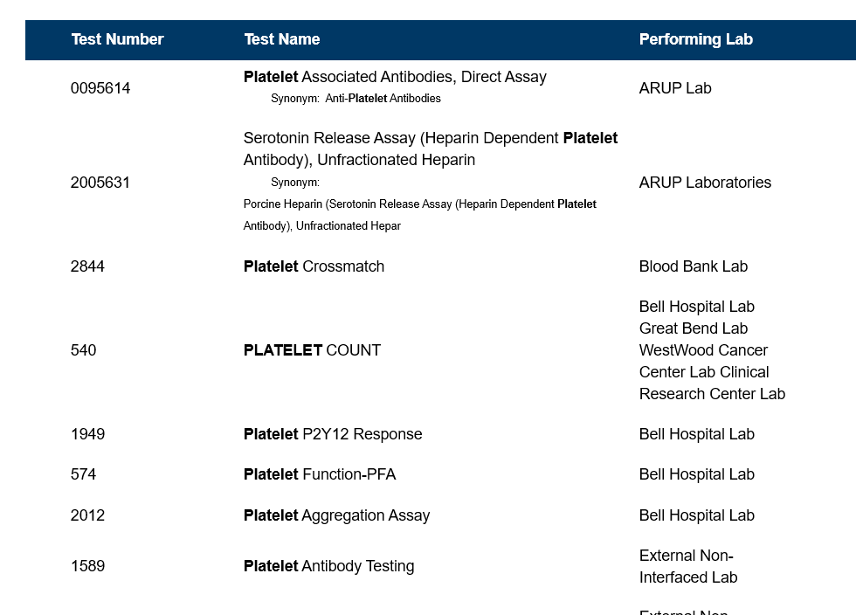

From the page below, select the Result Interpretation tab
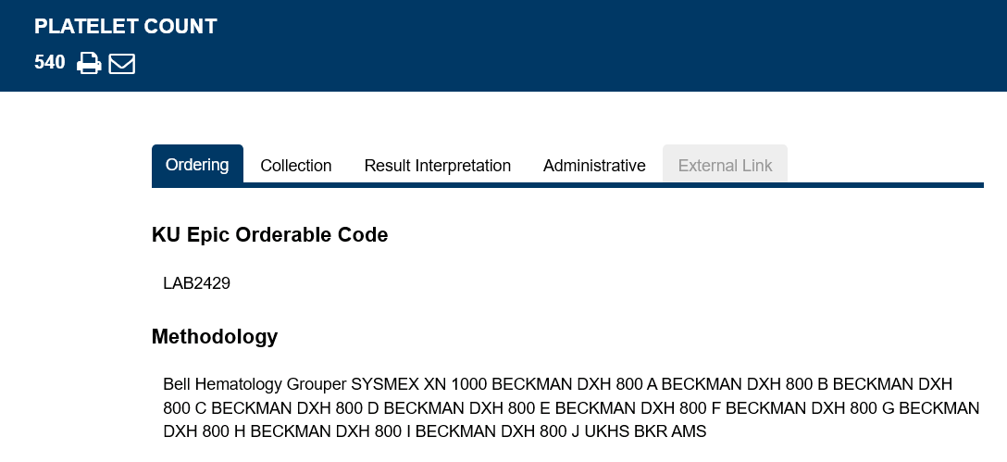
Please scroll to the next page
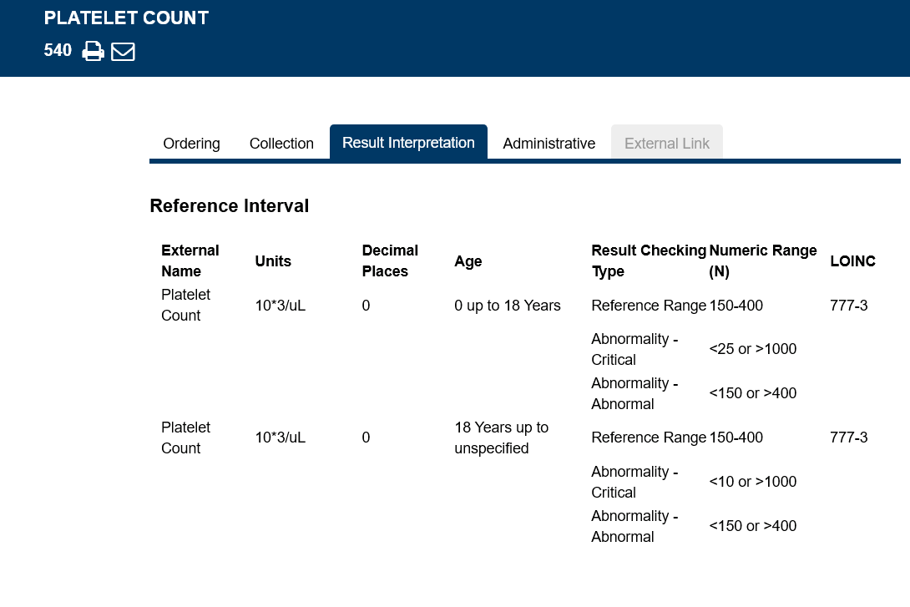
There is more information on the next page.

Some tests are located within “panels.” For example, the Absolute Blasts % is found within the Manual Diff test:
