Order of Draw for Evacuated Tube Blood Collection

- Verify that you are using a tube with the correct additive. Tube top colors may vary between manufacturers.
- Do not use expired tubes or tubes that have dropped on the floor.
- GENTLY invert all tubes immediately after collection. DO NOT shake tubes.
DRAW
ORDER
DRAW
ORDER
DRAW
ORDER
CONTAINER | ADDITIVE | Inversion | IMPORTANT INFORMATION
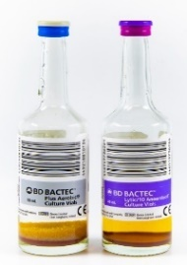  Blood Culture  Vials | Culture Medium | 8-10 times | - Collect specimen in both vials (aerobic and anaerobic). Adult minimum volume is 10 mL for each bottle.  - Must be drawn with winged collection device (using a discard tube) or a syringe (using a syringe transfer device).
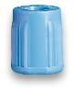  2.7 mL  (Light Blue)  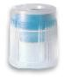  1.8 ml  (Light Blue) | Sodium Citrate  3.2% | 3-4 times | - Draw 1-2 mL of blood in a light-blue-top discard tube before filling sample tube.  - Sample tube MUST be filled to indicator line for valid test results.  - Do NOT remove clots or send clotted specimens.  - Do NOT add two partially filled tubes together.
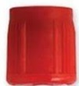  Red (Serum) | Clot Activator (no gel) | 5 times | - Use for serum collections when Gel Barrier tubes should NOT be used
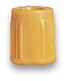  Gold with  Gel Barrier  (serum) | Clot Activator  Gel Serum  Separator | 5 times | - SST for serum determinations in Chemistry  - Invert tubes to ensure proper mixing of clot activator. Clotting time 30 min.
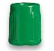  Green  (Plasma)  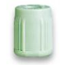  Green w/Gel (Plasma) | Lithium Heparin  Lithium Heparin Sep (Gel)  Sodium Heparin | 8-10 times | - These tubes are NOT interchangeable.
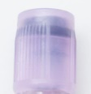  Lavender  (Plasma/ whole blood) | EDTA K2 | 8-10 times | - Do NOT remove clots or send clotted specimens.
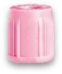  Pink (Plasma/ whole blood) | EDTA K2 | 8-10 times | - Do NOT draw for CBC  - Do NOT remove clots or send clotted specimens
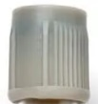  Gray  (Plasma) | Sodium Fluoride/ Potassium Oxalate | 8-10 times | - Routinely used for glucose testing  - Do NOT remove clots or send clotted specimens
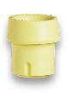  Yellow  (Whole blood) | ACD Solution | 8-10 times | - Solution A and Solution B tubes are interchangeable.  - Do NOT remove clots or send clotted Specimens

Note: These are some common tubes used in Medstar laboratories to perform testing. For special tubes not included in this list, please call lab.

