CLEAN CATCH URINE COLLECTION
FEMALE

This test is done to check for bladder or urinary tract infections. It is very important you follow these steps to obtain the best sample possible.

- Wash your hands with soap and water. Rinse and dry your hands well.

- Use the urine sample cup and 3 wipes.

- Put a clean paper towel or cloth on a place you can reach from the toilet.

- Open the wipes and place them on the towel.

- Take the lid off the cup. Put the lid flat side down next to the wipes. Do not touch the inside of the cup or lid.

- Sit as far back on the toilet as possible and spread your legs apart. Use two fingers of one hand to spread open your labia. The labia are the folds of skin on each side of your vagina. Hold the labia open like this until you get the urine sample.
7. With your other hand, use the wipes to clean your labia.

Wipe from front to back in one stroke. Throw the wipe in the toilet.

Use the second wipe to clean again from front to back. Throw the wipe in the toilet.

Use the third wipe to clean one last time from front to back. Throw the wipe in the toilet.

8. Pick up the cup.

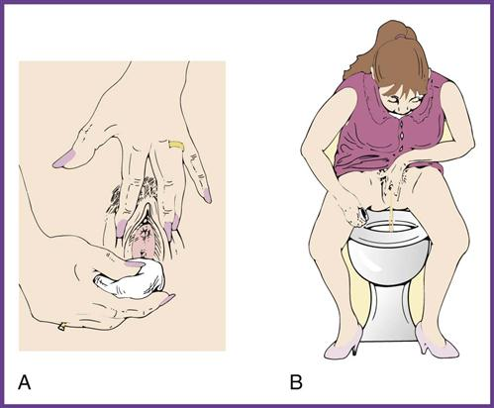

9. Urinate a small amount into the toilet then put the cup a few inches from your body. Move cup to the flow of urine and urinate into the cup until it is about half full. Stop the flow. Place the cup back on the towel/cloth near you. Let go of your labia and finish urinating into the toilet.

10. Put the lid tightly on the cup. Be careful not to touch the inside of the cup or lid.

11. Wash your hands.

12. If you are in the hospital, give the sample to the staff. If you are at home, put the cup in a plastic bag. Put the bag in the refrigerator. Take it to the lab or doctor’s office as directed.

Test results are sent to your doctor. Your doctor will share the results with you.

