CLEAN CATCH URINE COLLECTION
MALE

This test is done to check for bladder or urinary tract infections. It is very important you follow these steps to obtain the best sample possible.
- Wash your hands with soap and water. Rinse and dry your hands well.

- Use the urine sample cup and 3 wipes.

- Put a clean paper towel or cloth on a place you can reach from the toilet.

- Open the wipes and place them on the towel.

- Take the lid off the cup. Put the lid flat side down next to the wipes. Do not touch the inside of the cup or lid.

- Pull back on the fold of skin around the tip of your penis if you are not circumcised.

7. Wash the end of your penis with a wipe. Throw the wipe away.

8. Wash your penis with the second wipe. Throw the wipe away.

9. Wash your penis with the third wipe. Throw the wipe away.

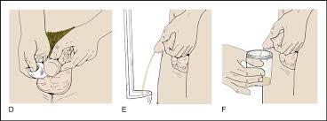
10. Pick up the cup.

11. Start to urinate a small amount into the toilet.

12. Put the cup into the urine stream. Collect the urine in the cup until it is about half full. Finish urinating in the toilet.

13. Put the lid tightly on the cup. Be careful not to touch the inside of the cup or lid.

14. Wash your hands.

15. If you are in the hospital, give the sample to the staff. If you are home, put the cup in a plastic bag. Put the bag in the refrigerator. Take it to the lab or doctor’s office as directed.

Test results are sent to your doctor. Your doctor will share the results with you.

