Procedure for Midstream Clean Catch Urine Sample

PLEASE READ INSTRUCTIONS COMPLETELY BEFORE BEGINNING
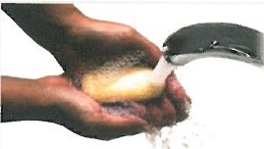

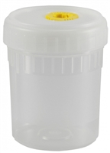
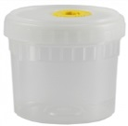

Step 1: At the sink, wash your hands COMPLETELY using soap and warm water for at least 20 seconds.

Step 2: Remove urine cup from packaging.

Step 3: Hold the cup by the sides. Carefully
remove lid without touching the inside of the cup.

Step 4: Place lid upside down on a flat surface.
Step 5: Open sealed packets containing sterile cleansing towelettes.
DO NOT use on hands. This is for cleansing the genital area. (See step 6.)

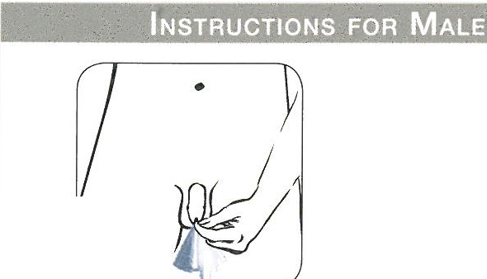
Step 6: MALE - Use the first sterile cleansing towelette beginning at the end of penis & clean backward toward the body. Retract foreskin if
uncircumcised.
Use a second sterile cleansing towelette & repeat the process.

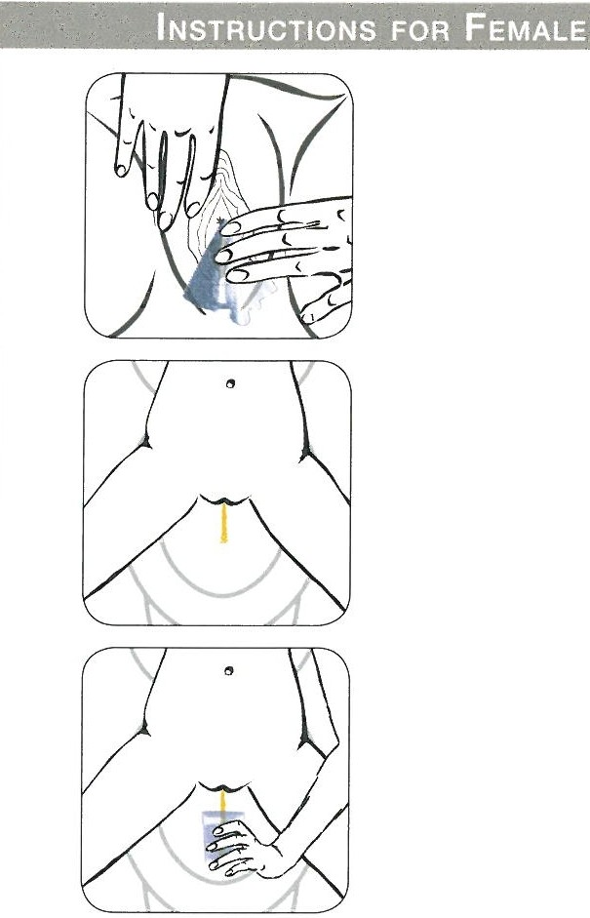
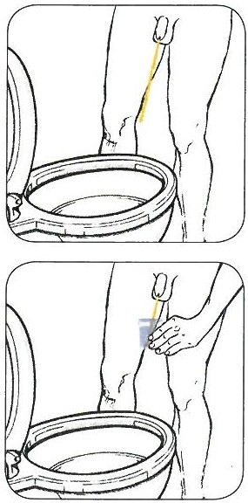
Step 7: MALE - Begin urination & allow a small amount of urine to go into the toilet.
Step 6: FEMALE - Use the first sterile cleansing towelette to clean the urethral opening &
surrounding area. Make sure all folds of skin are separated & cleaned. Use a second sterile cleansing towelette & repeat the process.

Step 7: FEMALE - Begin urination & allow a small amount of urine to go into the toilet.
Step 8: FEMALE - Hold the open urine cup by the sides. Continue urination & place open urine cup in urine stream. Hands & body parts MUST NOT
touch the inside or lip of the cup. Any remaining urine should go into the toilet.

Step 8: MALE - Hold the open urine cup by the sides. Continue urination & place open urine cup
in urine stream. Hands and body parts MUST NOT touch the inside or lip of the cup. Any remaining urine should go into the toilet.

Step 9: Hold the sterile yellow lid by the sides & tightly screw it onto the urine cup.

Step 10: Wipe the outside of the urine cup with a paper towel to remove any urine.

Step 11: Give sample to a healthcare professional immediately & wash hands completely with soap and warm water.

-

