VACUETTE® Urine Collection System Instructions for Use

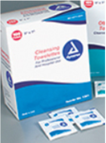 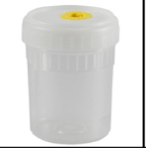  [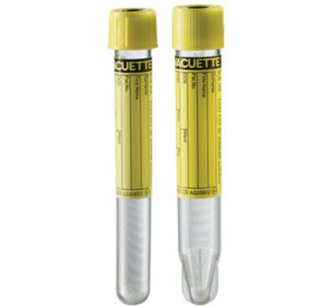](https://www.google.com/url?sa=i&rct=j&q=&esrc=s&frm=1&source=images&cd=&cad=rja&uact=8&ved=0CAcQjRw&url=https://www.dabossupplies.com/index.php?route%3Dproduct/product%26product_id%3D1111&ei=OxgkVfatFci2sAXSkIOoAw&bvm=bv.89947451,d.b2w&psig=AFQjCNHmJzTNaESRdAsib3IVb0_y5zCz8Q&ust=1428515220565678) [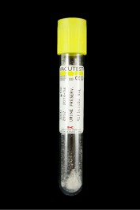](http://www.elkaylabs.com/images/content/products/Vacutest_urine_collection_tube_9ml_16_x_100_with_preservative_U149600.jpg)

Personal wipe Urine collection cup Transfer device Round bottom Conical bottom Preservative tube



**1  2**  **3**  **4** **5** 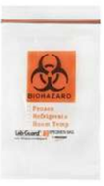

Send labeled tubes double-bagged to the laboratory for testing. Dispose of the urine cup. Do NOT send cup to lab.

Provide patient with the included personal wipe to cleanse site prior to collecting urine sample. Collect urine sample in the provided cup.

Insert the urine transfer device into the urine cup via the port in the lid being careful to maintain the sterility of the straw.

Insert the tubes into the urine transfer device. Fill the tubes in the following order: 1.) Conical tube 2.) preservative tube 3.) round bottom tube

Invert the preservative tube 6-8 times. Label each tube in the presence of the patient. Dispose of the urine transfer device in a rigid biohazard bin.