
Sarah Bush Lincoln Laboratory Critical Values/ Result List

PURPOSE
The purpose of this list is to identify the laboratory tests and their respective critical high and critical low values/results. This list pertains to testing that is performed in Sarah Bush Lincoln Laboratory.

DEFINITION
A Critical Value / Critical Result is defined as:
A value/result that represents a pathophysiological state at such variance with normal (expected values) as to be life-threatening unless something is done promptly and for which some corrective action could be taken.

NOTE:
The critical values identified on this list will be communicated to clients in accordance with notification standards.
Blood Gas Critical Values
Assay Description |  | Critical Low | Critical High
Carbon Monoxide |  |  | >10
Methemoglobin Arterial |  |  | >2.9
Methemoglobin Venous |  |  | >2.9
Partial Pressure CO2 Arterial |  |  | >60
Partial Pressure CO2 Capillary |  |  | >60
Partial Pressure CO2 Venous |  |  | >70
Partial Pressure O2 Arterial |  | <60
Partial Pressure O2 Capillary |  | <35
pH Arterial |  | <7.20 | >7.6
pH Arterial Cord |  | <7.15
pH Capillary |  | <7.20 | >7.6
pH Cord Ven |  | <7.15
pH Venous |  | <7.15
Potassium (Whole Blood) |  | <3 | >6.4

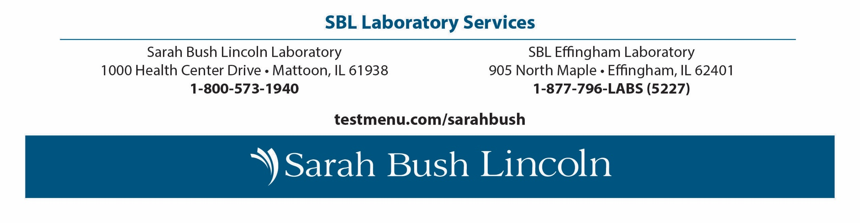

Laboratory Critical Values
Sarah Bush Lincoln Laboratory Critical Values/ Result List
Assay Description | Age From | Age To | Critical Low | Critical High
Anion Gap |  |  |  | >20
Bilirubin |  |  |  | >15
Calcium Level |  |  | <6 | >12
Carbon Dioxide |  |  | <10
Digoxin Level |  |  |  | >2
Glucose Level |  |  | <50 | >450
Lithium Level |  |  |  | >1.5
Magnesium Level |  |  | <1 | >5
Potassium Level | 0 Months | 3 Months | <3 | >6.4
Potassium Level | 3 Months | 150 Years | <2.5 | >6
Sodium Level |  |  | <120 | >160
hs-cTroponin-I (MALE) |  |  |  | >99
hs-cTroponin-I (FEMALE) |  |  |  | >75
INR |  |  |  | >6
D-Dimer (Quant) |  |  |  | >1.06
Heparin, Xa, LMWH |  |  |  | >1.99
Heparin, Xa, Unfractionated |  |  |  | >1.99
Partial Thromboplastin Time |  |  |  | >150
Prothrombin Time |  |  |  | >70.9
Blast % Manual |  |  |  | >5
Hemoglobin | 0 Minutes | 1 Months | <8 | >24
Hemoglobin | 1 Months | 150 Years | <7 | >20
Oncology Platelets |  |  | <20 | >1000
Platelets |  |  | <50 | >1000
Vancomycin Random (Outpatient) |  |  |  | >25
Vancomycin Trough (Outpatient) |  |  |  | >30
Blood Cultures | Any positive bacterial growth
Meningitis PCR Panel | Detected Organism
Urinalysis | Strongly-positive tests for glucose & ketones in all ages and previously-undiagnosed adults.
Revised 4/23/26

