A message from Adam Morgan, M.D. (Laboratory Medical Director | SSM Health St. Mary’s Hospital - Madison) ...

Non-Gynecologic Cytology Specimen Collection
Notification Date: 1/21/26
Effective Date: 2/9/26
SUBJECT: Change in Collection Container and Fixative for Non-Gynecologic Cytology specimens.

Effective Monday, February 9, 2026, we will be transitioning from the Yellow Top Jars (containing 50% Ethanol) to the Light Blue Top CytoLyt Jars (containing CytoLyt Solution) for primary non-gynecologic cytology specimen collection and fixation.

Previous Container | New Container
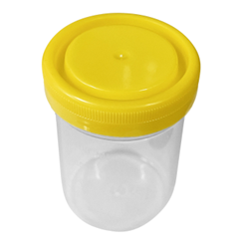 | 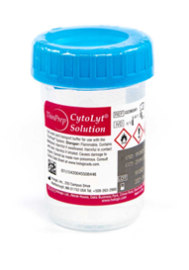
Yellow Top Jar | Light Blue Top CytoLyt Jar
50% Ethanol (Alcohol) | CytoLyt Solution

This transition is being made to improve the quality and processing of non-gynecologic cytology specimens. The CytoLyt solution is a PreservCyt-based fluid that offers several advantages over alcohol fixation.

**Note:** Specimens collected in 50% Ethanol will continue to be accepted until current stock is used up.

Please direct questions or comments to:
Jenel Liphart
608-259-3441
jenel.liphart@ssmhealth.com

Please communicate to colleagues and staff in your area accordingly.

Thank you,
Adam Morgan, M.D.
Laboratory Medical Director
Pathology, SSM Health St. Mary’s Hospital Madison
700 South Park Street
Madison, WI 53715
Office: (608) 258-6914

