**Urine Collection Kit Safety Advisory**

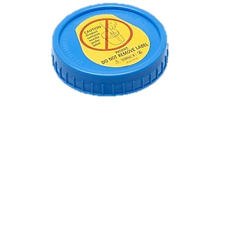

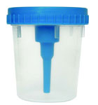

CAUTION: Appropriate care should be used in handling the screw cap lid of the BD Vacutainer® Urine Collection Cup, which contains a needle under the label. Treat the screw cap of the cup as a contaminated sharp and discard in biohazard container approved for sharps after transfer into both urine tubes provided.

**Instructions for Use of BD Vacutainer® Urine Collection Cup:**

1. The healthcare professional obtains a cup for the patient and cautions patient not to remove the cap label to protect against needlestick from the “sharp” contained in the integrated transfer device. The healthcare professional should remove the BD Vacutainer® Tubes and place them in a protected location before giving the cup to the patient for urine collection.

2. The patient should be directed to follow instructions for proper collection of a clean-voided, midstream urine specimen.

3. Patient is instructed to give the urine specimen to the healthcare professional immediately after collection.

4. Healthcare Professional must label the urine container at the patient’s bedside using the two patient identification process.

**To transfer the specimen into evacuated tube(s):**

1. Place cup upright on clean, flat surface. Container may be tipped at an angle if specimen volume is limited.
2. Peel back label on cap (do not remove it) to expose the integrated transfer device.
3. Place evacuated tube into cavity on cap, stopper down. Advance the tube over puncture point to pierce stopper. BD Vacutainer® C&S Preservative Urine Tubes should be filled first when collecting multiple tubes.
4. Hold tube in position until filled.
5. Remove tube from integrated transfer device.
6. For all BD Vacutainer® Preservative Urine Tubes, mix tubes 8 - 10 times by inversion.
7. Carefully replace label over integrated transfer device cavity and reseal. Use caution to avoid contact with needle when replacing label.

4. Label tube(s) and cup using the two patient identifier process for transport to laboratory.

5. Deliver all specimens to the ED Liaison. Do not transport the cup through the tube station, sharps are prohibited.

6. For transport of cup to the laboratory, and to protect against inadvertent needlesticks caused by a sharp, always ensure the needle is covered with the original label.  If you misplace the label, please place a sticker over the sharp.  Never wrap cup in parafilm or any other material for transport.