# Anatomic Pathology Forms (Outside of OpTime)

Tip sheet for when a physician orders anatomic pathology on a specimen collected outside of OpTime

1. Ensure that the ‘*Anatomic Pathology’* order is placed in Careconnect under **Manage Orders**.

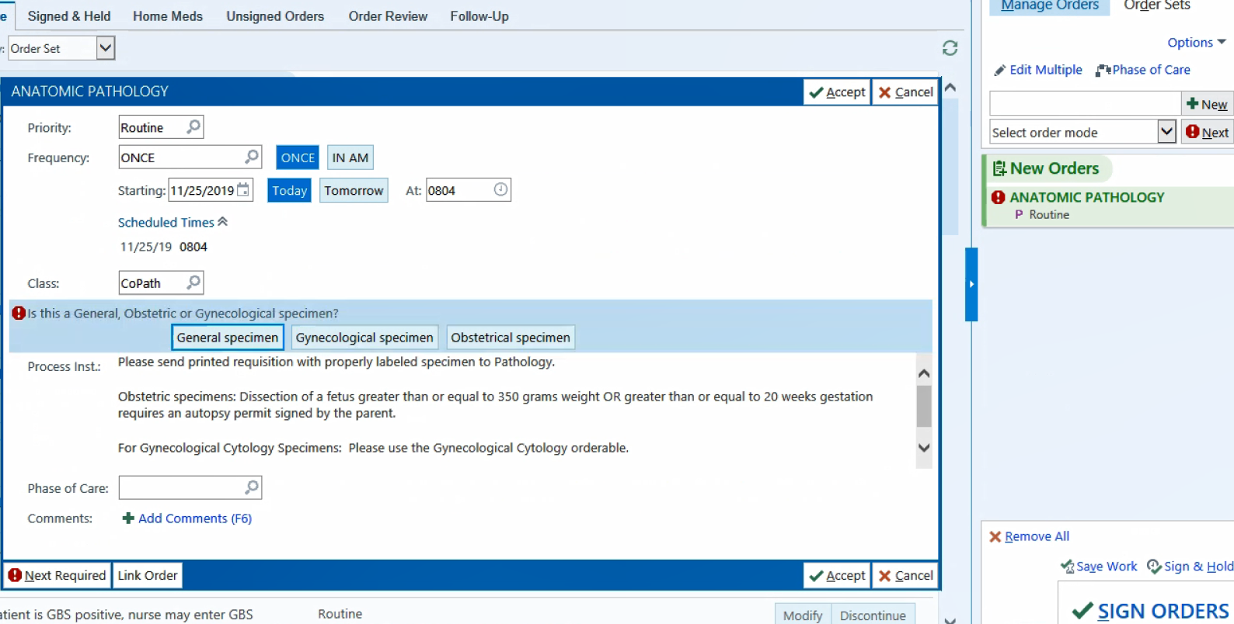

**Be sure to address all required fields within the order before signing.

1. Completing and printing the requisition form requires multistep collection from the **Summary** tab.

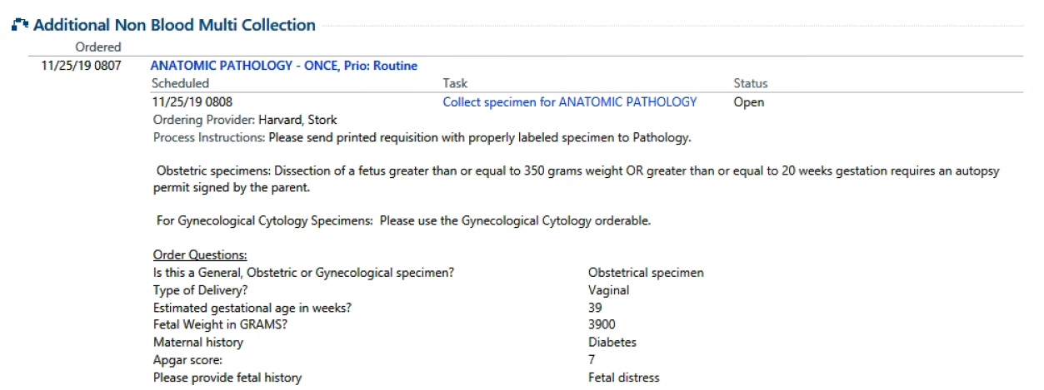

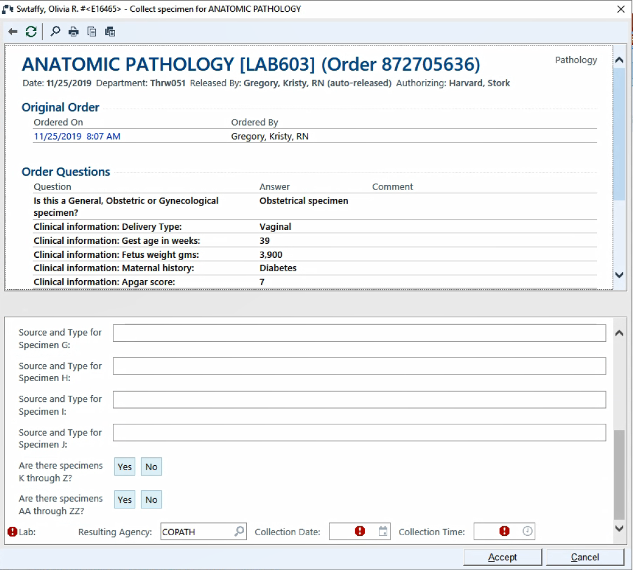

**A pop-up will present when you click on the collection link. Fill out all required information within the pop up and click ‘*Accept’* at the bottom right of the pop-up.

**Once you click ‘*Accept’* a requisition form will automatically print to the LAB for tracking purposes. Now you need to print one for yourself to go along with the specimen to pathology!!

1. You can view any printout you have generated by typing ‘*my printouts’* in the search field at the top right of the screen. From there you can select your printout that coincides with the pathology order and reprint it to your own printer. You can expand your list by clicking ‘*View More’* in the bottom left corner.

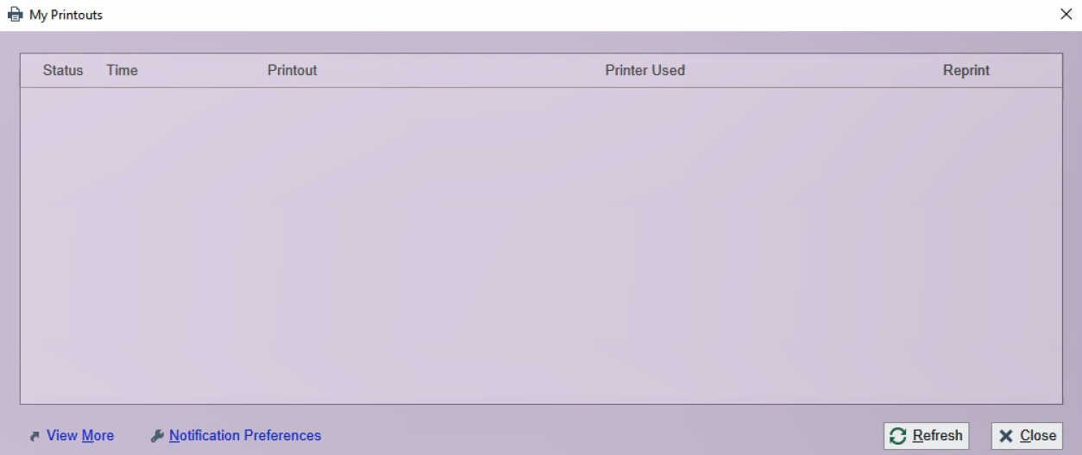

**Once you select the correct print job, be sure to change your printer to your unit before you print. Be sure to send the printout WITH THE SPECIMEN!