UCI Health

Invasively Collected Specimen Collection Containers, Microbiology Samples

Vendor/SKU # | Name of Container | Uses
Medline MKA2981  Medline  BD352037H | 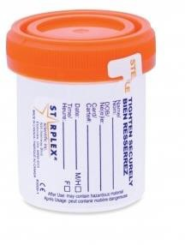  Sterile Specimen container (urine cup)  Falcon sterile tube with screw cap (fluid ONLY)  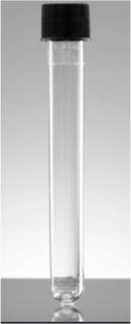 | - Fluid specimens: Aerobic, Anaerobic (includes aerobic), AFB, Fungal cultures  - Tissue: Aerobic, AFB, Fungal cultures (0.25 gm to 1 cm³).  Add up to 1ml of non-bacteriostatic saline to prevent drying.  Unacceptable solutions: alcohol and formalin  - Non-biological/hardware  Do not place sample (e.g. tissue, blood clot) on gauze  Anaerobic culture (deliver immediately to lab)  Stability 1 hour at room temperature  Stability: ambient: 24; Refrigerated: 2 days; Frozen: unacceptable
Medline  ANRAS914  ANRAS915PK  Medline  ANRAS911  ANRAS919 |  | Anaerobic cultures. It can be shared with Aerobic, AFB and Fungal culture.  - Tissue: (0.25 gm to up 1 cm³)  - Fluid: minimum 1mL. Small volume (< 1mL) should be collected in a sterile screw-cap tube  - Swab: not recommended for surgical samples  Stability in ATM: ambient: 24; Refrigerated: 2 days; Frozen: unacceptable
  Anaerobic Transport Medium  Surgery Pack  (ATMSP) AS-914  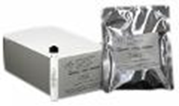 | Anaerobic Tissue Transport Medium Surgery Pack  (ATTMSP) AS-915  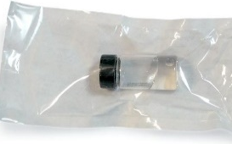
  Anaerobic Transport Medium (ATM)  AS-911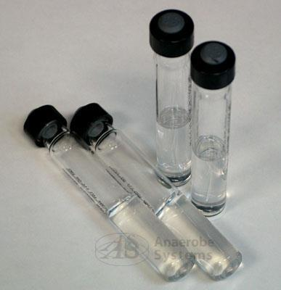 |  | Anaerobic Tissue Transport Medium (ATTM) AS-919  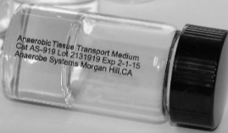
Medline  B-D220145H | BBL CultureSwab™  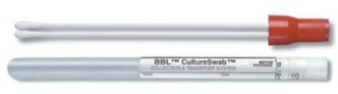 | Aerobic culture. ONLY when NO fluid or tissue is available.  Stability in ATM: ambient: 24; Refrigerated: 2 days; Frozen: unacceptable  Not recommended for AFB and Fungal cultures
Version 6/24/2026

