Welcome to Laboratory Test Menu, UMMC’s online test directory quick tip information guide.
It contains laboratory test information to assist providers during ordering, specimen collection, as well as result interpretation.
All tests published on the Laboratory Test Menu website are orderable at UMMC.
There are several ways to access it utilizing EPIC as well as the UMMC Intranet/Internet.
EPIC Portfolio has two access options: General ‘Links’ and the EPIC Patient Summary Document Link.
Option 1: General ‘links’ section:
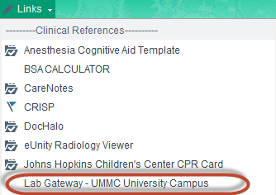
Option 2: The ordering menu Patient Summary contains a Document link:
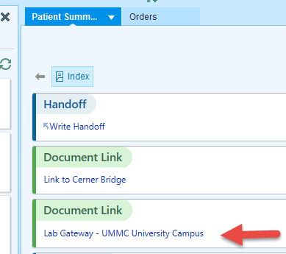

The UMMC Intranet/Internet web page has four access options.
Option 1: Laboratories of Pathology home page
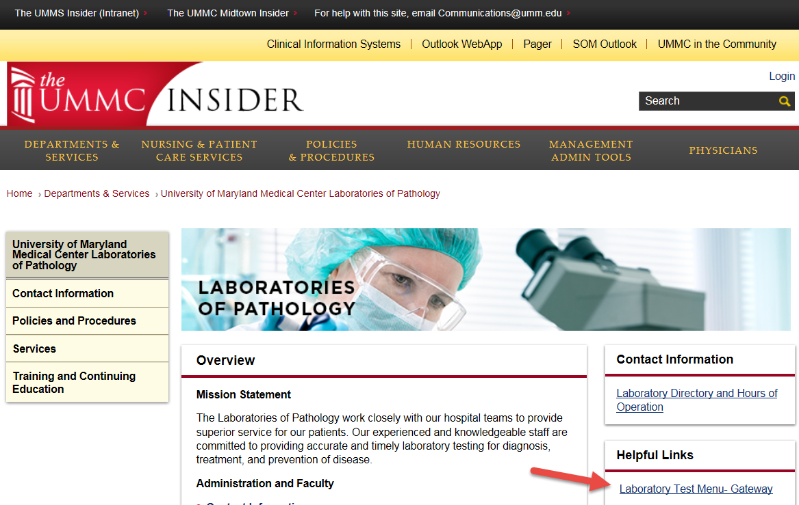
Option 2:
Intranet Clinical and Business Information Systems: http://web.umm.edu/cislinks.htm
Option 3:
intra.umms.org/ummc - Patient Care Quick Links:
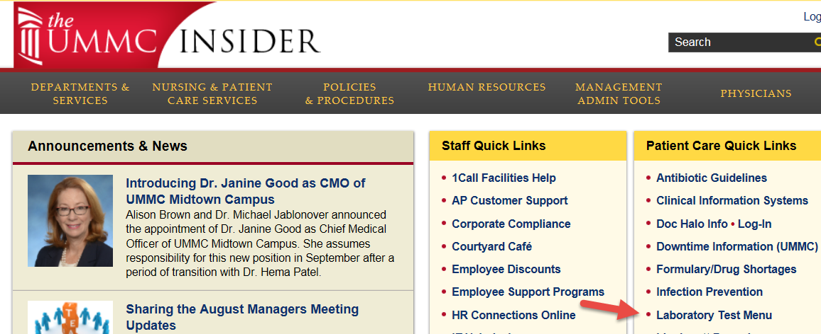
Option 4:
Type www.testmenu.com/ummc into your browser on your computer or phone
Welcome:
The search box is the portal to getting the right test information.
The side panel contains a general grouping of test categories as well as any New ( ) or Updated ( ) tests.
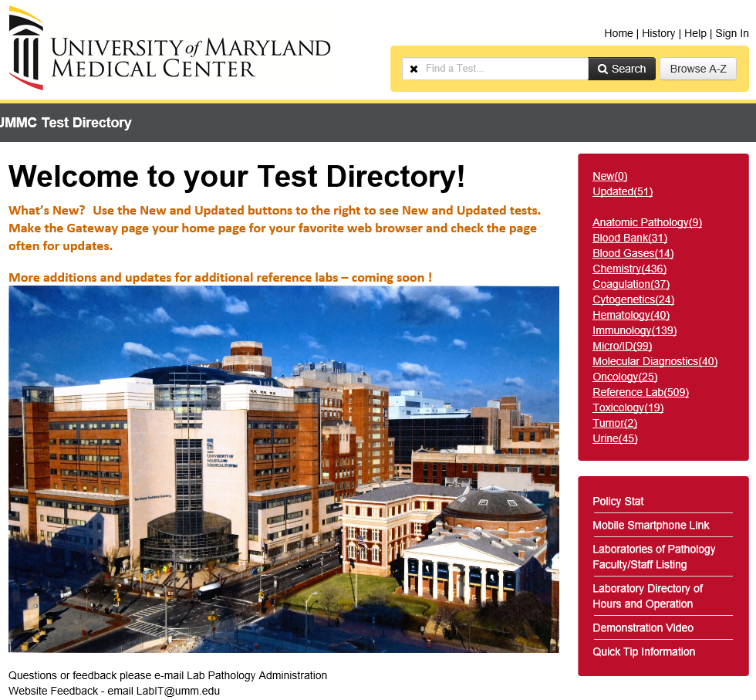
Type the test in the Search box: (example CBC or Complete Blood Count)
Ordering tab – Ordering considerations, when the test is performed, what is the Turn Around Time, additional test synonyms, Epic test code (LAB#), any outside lab test code, and where is the test performed.
Collection tab – Collection information, Specimen Preparation, Unacceptable Conditions, Storage/Transport Temperature, Stability (from collection to initiation), when is the test performed, where is the test performed.
Result Interpretation tab – Reference Intervals and Interpretative Data.
Administrative tab - contains CPT code information and if the test is outsourced, the outsource test number.
Example test page:
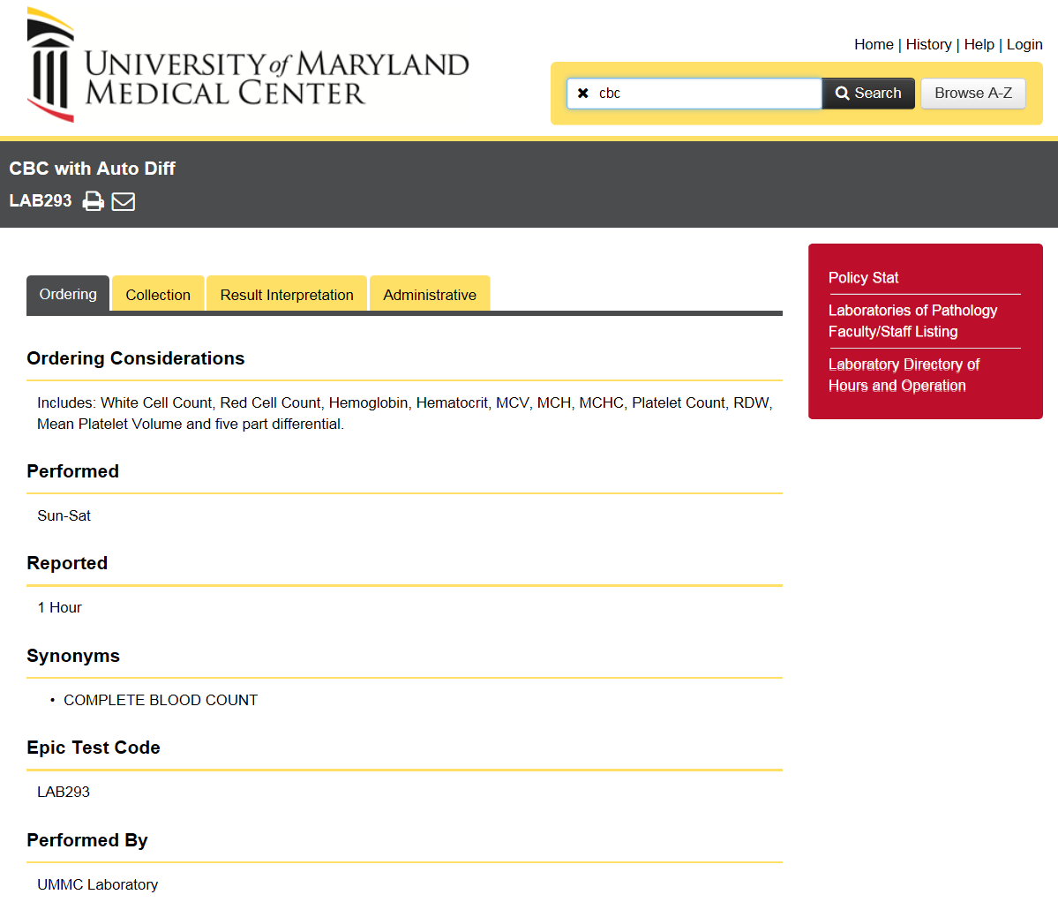
You do not need to Login to see any test directory information.
Test can be grouped into more than one category on the side right panel.

