Occupational Health (Employee Health) Patients
Create a New HOV

CLICK on Create New Account

On the Hospital Account Screen Click on Encounter Form under the Patient’s Name in the Left Hand Column.
Locate the Specialty billing > Billing Flag field.
Type in CL01972 into the Billing Flag Box and press tab
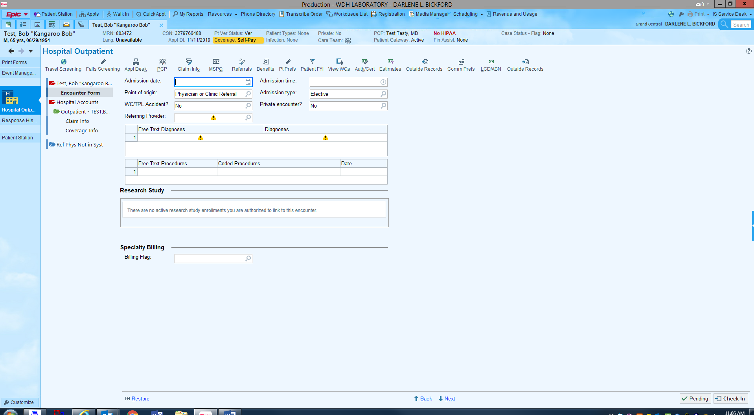
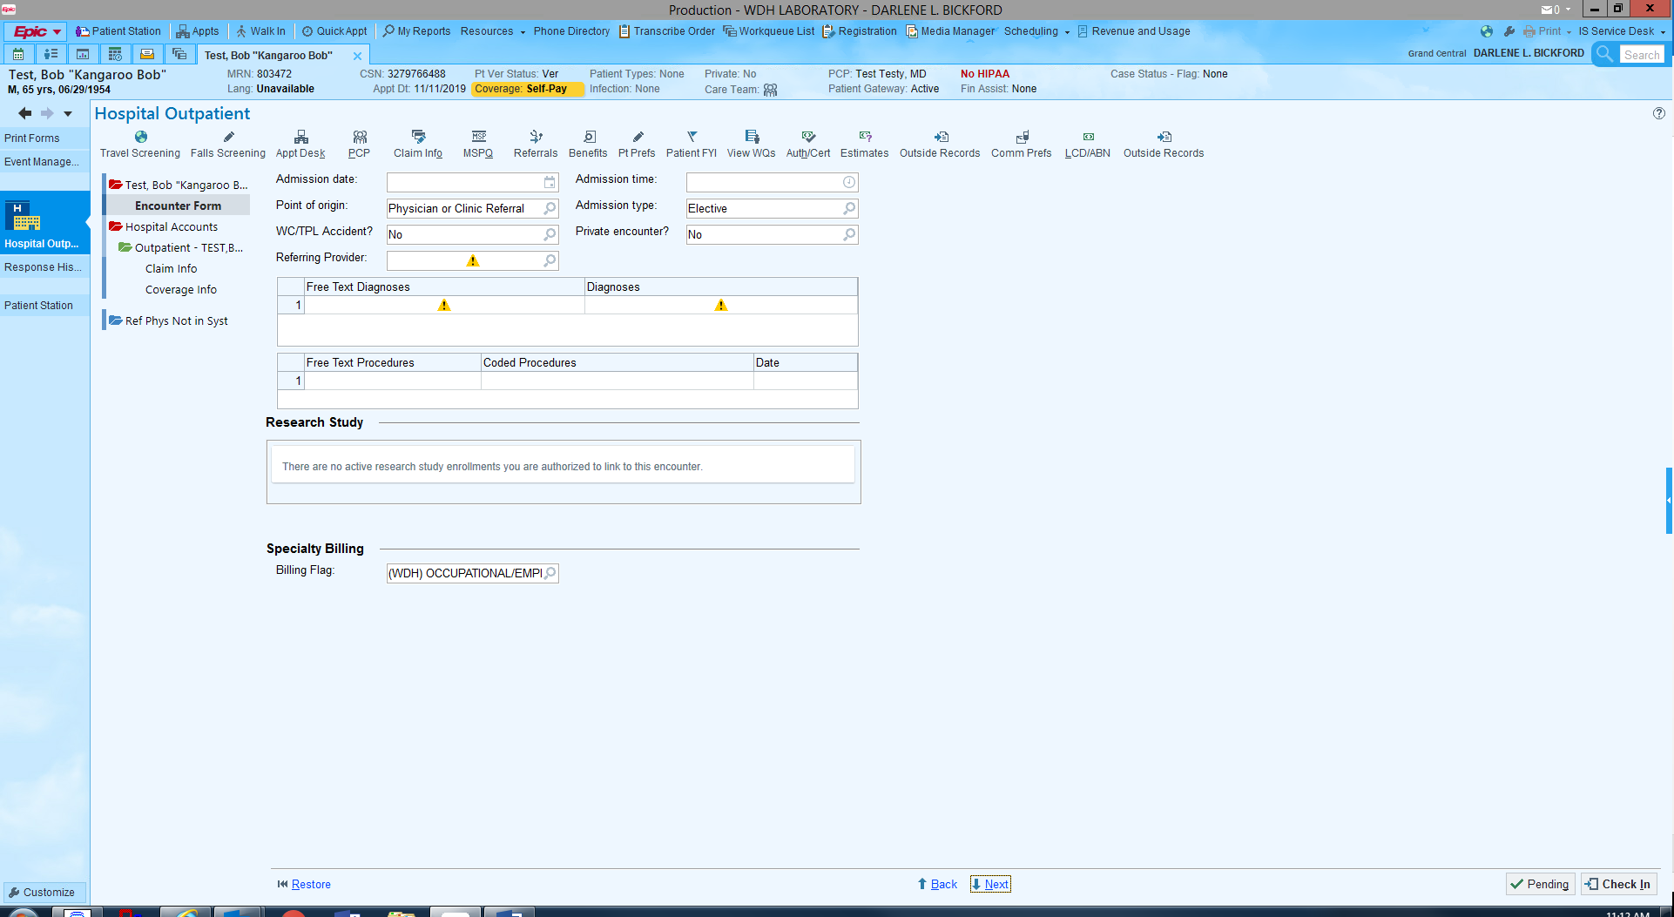
Click CHECK IN to complete the HOV.
NOTE: You will not need to enter NO CHARGE into Sunquest as previously instructed

