ADD-ON REQUEST PROCESSING INSTRUCTIONS
- EPIC Add-Ons will be generated by the physician electronically using one of the following add-on codes with a free text comment indicating which test they would like.
  - LADDON = General lab add-on
  - MADDON = Micro Add-On
  - BADDON = Blood Bank Add-On
*Please note, although they should only put one test per request often time the physician adds more than one test, please process each test indicated*
- All EPIC entered Add on requests will print on the CAT room printer. You will work from the Add-On Paper Requisition.
- All outpatient Add-on requests will be faxed
1. Processing Current Day Outpatients, Inpatient and or ED Add-Ons for Epic transmitted requests
- Log onto SQ > Gen Lab > Order Receipt/Modify
- Scan or enter Patient MRN
- Click on Display Orders. (This will default to 1 day of activity)
  - OUTPATIENTS: If there aren’t any specimens for the current day to add to See the “Add-On request to Historical Outpatient Specimens (1-3 days old)”
  - INPATIENT/ED PATIENTS: If there are NO current day specimens available:
    - Click on query to return to the Order Access Screen
    - Change Day(s) of Activity to no more than 3.
    - Click on Display Order.
- Review the historical orders to determine if add on is possible.
- If NO – Collect and Receive the Add-On test accession.
  - In ADDSTA field enter ADDU (unable to add test)
- If Yes – Proceed
- Write down the following:
  - Original collection date and time
  - Original receipt date and time.
  - Reprint the label for the tube you will add to or write down the CID
- Close out of Order Receipt/Modify

Log onto Cobas Infinity to locate Sample (Refer to Sample Retrieval training document for more details)
- Select Lab Flow (1)
- Click on the Main (2)Tab> Click on the down arrows beside Menu >Select Work Flow >Sample Tracking
(1)
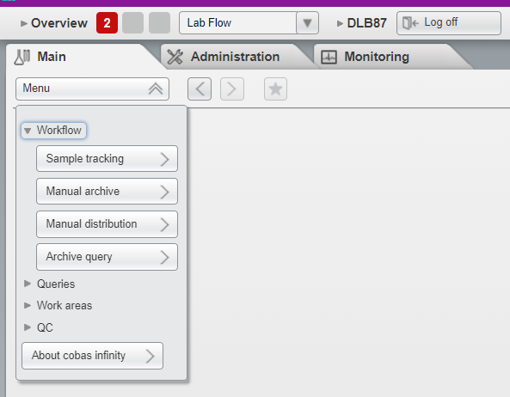
(2)
TIP: Add the Sample Tracking to your Favorites by clicking on the box with the Star. This will add it to the Overview page and allow for quick one click access to Sample tracking.

- Change the Order Regist… From To field to ALL (default Since Yesterday) (3)
- Enter the Tube Identification (4) or Scan (CID number) > Press Enter

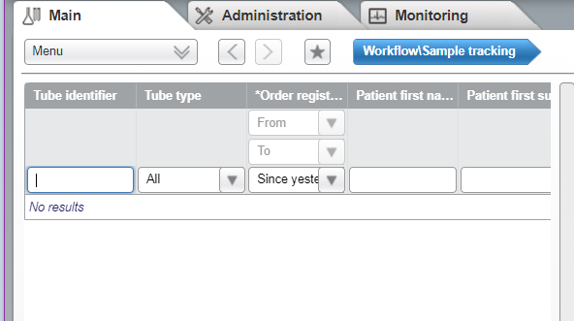
(3)
(4)
- The Tracking results will appear to the Right.
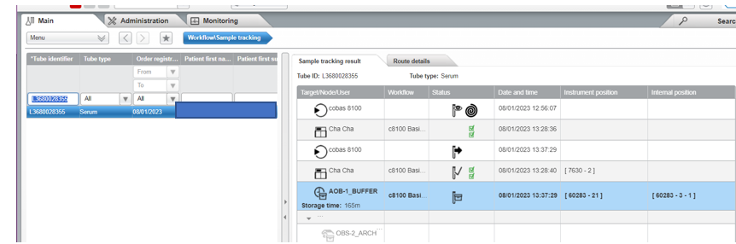
(5)
- Samples can only be Electronically retrieved if in the AOB-1 Buffer
  - If the samples are in the OBS-2_ARCH, Chemistry Manual Archive or Heme Manual Archive you will need to manually retrieve the sample See Manual retrieval section.
- For specimens in the AOB-1Buffer Click on Sample Quality (6) (the option at the bottom left with the down arrow)
- Click on Forced Target (7)
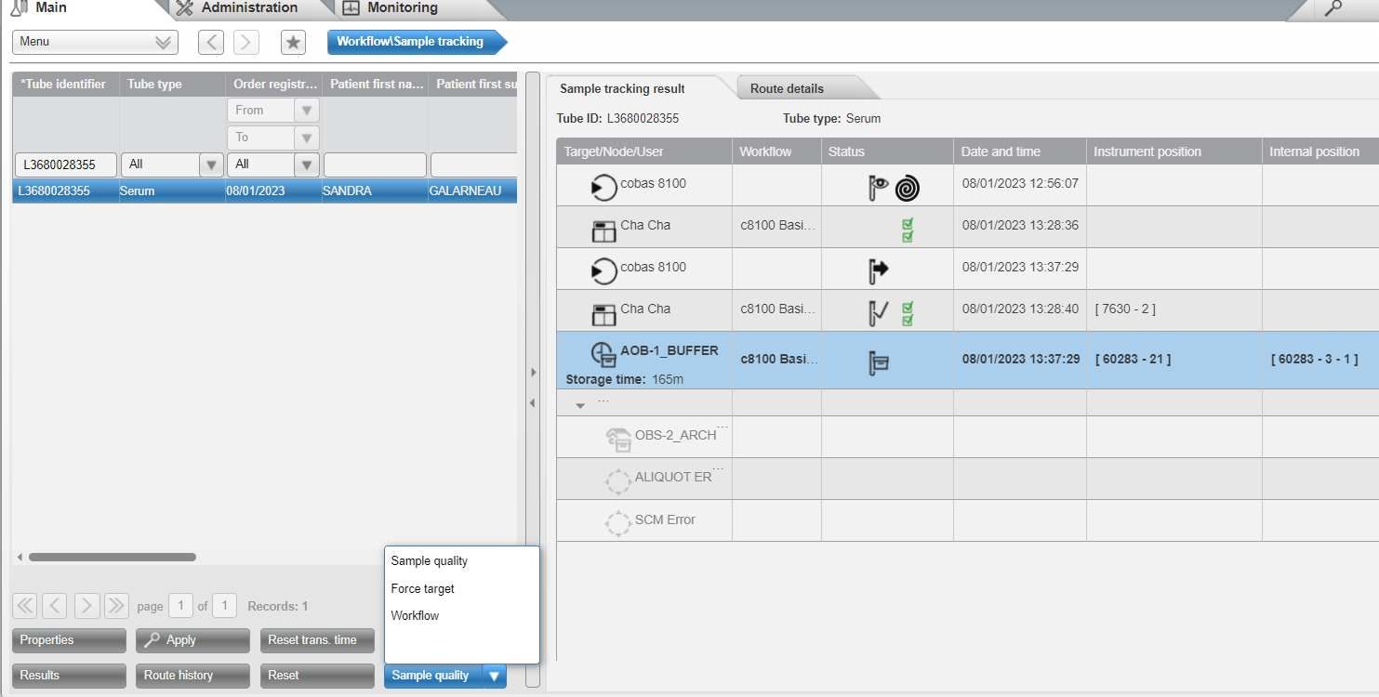
(6)
(7)
- The Tube selection, send to screen will appear.

- Use the drop-down arrow (8) for the Send to field to select Target.
- The Target menu will appear. Select Add-On to OBS (9), then select Force Target (10).
- The Sample will be delivered to the OBS1 Add-On Tray for retrieval.
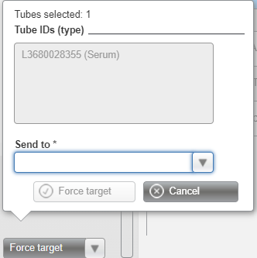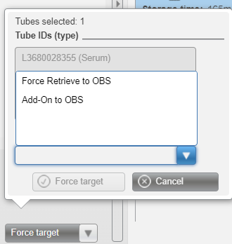
(8)
(9)
(10)
Log Out of Cobas Infinity and Return to Sunquest.
- Log onto SQ > Gen Lab > Order Receipt/Modify
- Enter MRN or Accession for the Add-on request
- Click onto the Add-on order
- Change Collection date and time to match the original specimen
- Change the Receipt date and time to also match the original specimen (DO NOT tab past this field)
- Click on the first blank spot under the LADDON (Addon test) in the Order code box and enter the test Code for the test being added
- Press Tab
- Click on SAVE
- The Container and Specimen Box will appear.
- Enter the container type from original sample
- A result entry box will appear
- Make sure all result field are filled in.
  - If the ADDCON and ADDTST fields are blank add NPRV in the field
- Enter ADDIP into the ADDSTA field
- Give the add on label to the Quarterback at the 8100 Place in designated spot….
Manual Retrieval:
- Follow Steps 1-5 above.
  - If the sample has been archived (off the 8100) or is ready to archive (still on 8100 in archive tray) the last location will be listed as OBS-2 ARCHIV, Chemistry Manual Archive or Heme Manual Archive (11) with a rack number and Instrument Position (12)
- In the Sample Tracking Results box, determine the Target and sample position (4th column to the right) The rack number will be the first number and the position will proceed the hyphen (example 60283-4 Rack 60283 position 4)
- Write down the sample location/position.
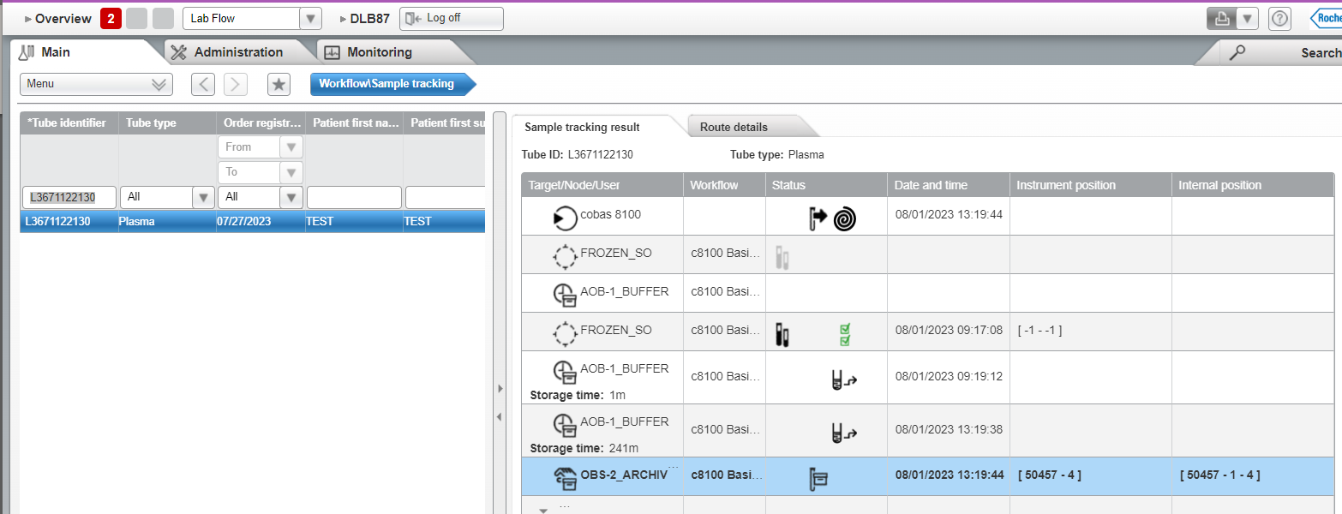
(12)
(11)
- Locate the rack and manually retrieve the sample from the rack leaving the spot empty
Log Out of Cobas Infinity and Return to Sunquest to complete the add on process.
- Verify the name and date of birth on the Sunquest Label matches the label on the specimen, once verified, label the sample and initial the label.
- Place the sample in the staging area in the appropriate location to be loaded onto the 8100.

2. Non-Epic Faxed Paper Add-On requests for Current Day.
- Order will be received via fax
- Log onto SQ > Gen Lab > Order Receipt/Modify
- Ener Patient MRN or Name
- Click on Display Orders. (This will default to 1 day of activity)
- Review for current orders to determine if the add on is possible.
  - If NO call the ordering physician’s office to notify them that the add-on is not possible.
  - If YES proceed
- Write down the following:
  - Original collection date and time
  - Original receipt date and time.
  - Reprint the label for the tube you will add to or write down the CID
- Close out of Order Receipt/Modify
Log onto Cobas Infinity to locate Sample (Refer to Sample Retrieval training document for more details)
- Select Lab Flow (1)
- Click on the Main (2)Tab> Click on the down arrows beside Menu >Select Work Flow >Sample Tracking
(1)
(2)
TIP: Add the Sample Tracking to your Favorites by clicking on the box with the Star. This will add it to the Overview page and allow for quick one click access to Sample tracking.
- Change the Order Regist… From To field to ALL (default Since Yesterday) (3)
- Enter the Tube Identification (4) or Scan (CID number) > Press Enter

(3)
(4)
- The Tracking results will appear to the Right.
(5)
- Samples can only be Electronically retrieved if in the AOB-1 Buffer
  - If the sample is in the OBS-2_ARCH, Chemistry Manual Archive and or Heme Manual Archive you will need to manually retrieve the sample See Manual Retrieval section.
- For specimens in the AOB-1Buffer Click on Sample Quality (6) (the option at the bottom left with the down arrow)
- Click on Forced Target (7)
(6)
(7)
- The Tube selection, send to screen will appear.
- Use the drop-down arrow (8) for the Send to field to select Target.
- The Target menu will appear. Select Add-On to OBS (9), then select Force Target (10).
- The Sample will be delivered to the OBS1 Add-On Tray for retrieval.
(10)
(9)
(8)
Manual Retrieval:
- Follow Steps 1-5 above.
  - If the sample has been archived (off the 8100) or is ready to archive (still on 8100 in archive tray) the last location will be listed as OBS-2 ARCHIV, Chemistry Manual Archive or Heme Manual Archive (11) with a rack number and Instrument Position (12)
- In the Sample Tracking Results box, determine the Target and sample position (4th column to the right) The rack number will be the first numbers and the position will proceed the hyphen (example 60283-4 Rack 60283 position 4)
- Write down the sample location/position.
(11)
(12)
- Locate the rack and manually retrieve the sample from the rack leaving the spot empty.
Log Out of Cobas Infinity and Return to Sunquest to complete the add on process and print the labels.
- Verify the name and date of birth on the Sunquest Label matches the label on the specimen, once verified, label the sample and initial the label.
- Place the sample in the staging area in the appropriate location to be loaded onto the 8100.

Log Out of Cobas Infinity and Return to Sunquest.
- Once you have obtained the specimen Open Order Entry >Create a NEW Accession for the Add-On test, making sure you select the appropriate Event
- Order enter the Add-On test being requested
- In the Modifier field enter ADDON-; (enter the accession number of the original accession you are pulling the sample from) Example: ADDON- ;T123456
- Enter any new DX codes in the DX code field.
- Enter the Collection date and time to match the original specimen
- Enter the Receipt date and time to also match the original specimen (DO NOT tab past this field)
- Press Tab
- Click on SAVE
- The Container and Specimen Box will appear.
- Enter the container type from original sample.
- Give the add on label to the Quarterback at the 8100 place in designated spot.

- EPIC Add-On request to Historical Outpatient Specimens (1-5 days old)
- Log onto SQ > Gen Lab > Order Receipt/Modify
- Scan or enter Patient MRN
- Change Day(s) of Activity to no more than 5
- Click on Display Orders
- Review the historical orders to determine if add on is possible.
- Write down the following:
  - Original collection date and time
  - Original receipt date and time.
  - Accession Number
EPIC – Create an HOV
All historical add-ons will need a NEW HOV dated with the “original” date of collection of the specimen being used for the add-on.
- Log onto EPIC
- Create a New Hospital Outpatient visit
- Enter the Original date of collection as the “Expected” date.

Log onto Cobas Infinity to locate Sample (Refer to Sample Retrieval training document for more details)
- Select Lab Flow (1)
- Click on the Main (2)Tab> Click on the down arrows beside Menu >Select Work Flow >Sample Tracking
(1)
(2)
TIP: Add the Sample Tracking to your Favorites by clicking on the box with the Star. This will add it to the Overview page and allow for quick one click access to Sample tracking.

- Change the Order Regist… From To field to ALL (default Since Yesterday) (3)
- Enter the Tube Identification (4) or Scan (CID number) > Press Enter

(3)
(4)
- The Tracking results will appear to the Right. Samples greater than 4 hours old will need to be manually retrieved as they will be in the OBS-2_ARCHIV

- If the sample has been archived (off the 8100) or is ready to archive (still on 8100 in archive tray) the last location will be listed as OBS-2 ARCHIV, Chemistry Manual Archive or Heme Manual Archive (5) with a rack number and Instrument Position (6)
- In the Sample Tracking Results box, determine the target and sample position (4th column to the right) The rack number will be the first number and the position will proceed the hyphen (example 60283-4 Rack 60283 position 4)
- Write down the sample location/position.
(6)
(5)
Locate the rack and manually retrieve the sample from the rack leaving the spot empty

Return to SunQuest
- Open Order Receipt/Modify
- Enter MRN or Accession for the Add-on request
- Click onto the Add-on order
Collect and Receive the LADDON (current day/time)
  - A result entry box will appear
  - Make sure all result field are filled in.
If the ADDCON and ADDTST fields are blank add NPRV in the field
- Enter ADDIP into the ADDSTA field
  - DO NOT enter the Add-On test.
- Open Order Entry >Create a NEW Accession for the Add-On test, making sure you select the appropriate Event
- Order enter the Add-On test code being requested
- In the Modifier field enter ADDON-; (enter the accession number of the original accession you are pulling the sample from) Example: ADDON-;T123456
- Enter any new DX codes in the DX code field.
- Enter the Collection date and time to match the original specimen
- Enter the Receipt date and time to also match the original specimen (DO NOT tab past this field)
- Press Tab
- Click on SAVE
- The Container and Specimen Box will appear.
- Enter the container type from original sample
- Verify the name and date of birth on the Sunquest Label matches the label on the specimen, once verified, label the sample and initial the label.
- Deliver specimen to 8100 to be loaded.

- Non-Epic Faxed Paper Add-On requests (>1 day)
- Log onto SQ > Gen Lab > Order Receipt/Modify
- Enter Patient MRN or Patient Name
- Change Day(s) of Activity to no more than 5
- Click on Display Orders
- Review the historical orders to determine if add on is possible.
- Write down the following:
  - Original collection date and time
  - Original receipt date and time.
  - Accession Number
EPIC – Create an HOV
All historical add-ons will need a NEW HOV dated with the “original” date of collection of the specimen being used for the add-on.
- Log onto EPIC
- Create a New Hospital Outpatient visit
- Enter the Original date of collection as the “Expected” date.
Return to Sunquest:
Log onto Cobas Infinity to locate Sample (Refer to Sample Retrieval training document for more details)
- Select Lab Flow (1)
- Click on the Main (2)Tab> Click on the down arrows beside Menu >Select Work Flow >Sample Tracking
(1)
(2)
TIP: Add the Sample Tracking to your Favorites by clicking on the box with the Star. This will add it to the Overview page and allow for quick one click access to Sample tracking.

- Change the Order Regist… From To field to ALL (default Since Yesterday) (3)
- Enter the Tube Identification (4) or Scan (CID number) > Press Enter

(3)
(4)

- The Tracking results will appear to the Right. Samples greater than 4 hours old will need to be manually retrieved as they will be in the OBS-2_ARCHIV

- If the sample has been archived (off the 8100) or is ready to archive (still on 8100 in archive tray) the last location will be listed as OBS-2 ARCHIV, Chemistry Manual Archive or Heme Manual Archive (5) with a rack number and Instrument Position (6)
- In the Sample Tracking Results box, determine the target and sample position (4th column to the right) The rack number will be the first number and the position will proceed the hyphen (example 60283-4 Rack 60283 position 4)
- Write down the sample location/position.
(6)
(5)
- Locate the rack and manually retrieve the sample from the rack leaving the spot empty
Close Cobas Infinity and Open Sunquest to complete the Add On process:
- Once you have obtained the specimen Open Order Entry >Create a NEW Accession for the Add-On test, making sure you select the appropriate Event
- Order enter the Add-On test being requested
- In the Modifier field enter ADDON-; (enter the accession number of the original accession you are pulling the sample from) Example: ADDON-;T123456
- Enter any new DX codes in the DX code field.
- Enter the Collection date and time to match the original specimen
- Enter the Receipt date and time to also match the original specimen (DO NOT tab past this field)
- Press Tab
- Click on SAVE
- The Container and Specimen Box will appear.
- Enter the container type from original sample
- Verify the name and date of birth on the Sunquest Label matches the label on the specimen, once verified, label the sample and initial the label.
- Deliver specimen 8100 to be processed.

