NEW PROCESS: Non-Gyn Urine Cytology/CSF Samples:

OVERVIEW - Summary of steps
- Non-Gyn Cytology orders are placed in EPIC and released to SQ
  - LAB 142 Urine Cytology Order SQ code: UCYTO
  - Lab 156 CSF Cytology Order SQ code: CCYTO
  - There will be a separate SQ tube label for the Cytology specimen.

- Specimens are delivered to the Clinical Lab processing area to be “received” using SQ function ORM
  - The status component test is Pending at this point.
  - If specimen is delivered to Pathology, Pathology will receive the specimen (see receiving instructions)

- Specimens ready to go to Pathology- (ready to deliver or be picked up)

- SQ Pending logs are available to assist with Order/Specimen management
  - Received orders pending log- lists Orders/specimens that have been collected and processed in SQ ORM by the clinical lab team.
  - Unreceived orders pending log- lists Orders that have been transmitted to SQ (indicating they were released from EPIC) but have not been processed by the clinical lab team.
    - Reasons- never collected or still in transit to the clinical lab processing area.
  - Note: once the status test is resulted it will no longer qualify for the Pending orders list.
- Specimens are tracked through the WDCYT spot to close out order by automatically resulting the Cytology Order Status test component

- Pathology will accession the Non-GYN urine/CSF order into CoPath per current practice
  - Cytology staff will print the EPIC requisition to provide necessary patient information

Sunquest Log-in
There are two applications that are utilized when using the Sunquest lab system
SQ-GUI: This is where the majority of modules are accessed, including but not limited to:
- Order Receiving modules
- SMART Tracking
- Lab Inquiry
SQ1-Smarterm: This is a legacy format of the application and used in a limited fashion as the vendor moves modules from a “roll and scroll” model into a windows-based format. Some of the SQ1 functions used regularly (not a complete list):
- Pending logs

Log-on SQ-GUI
Click on Sunquest LAB icon in your Applications list:
There is pop up box that will “Ask your Permission… “ Click YES
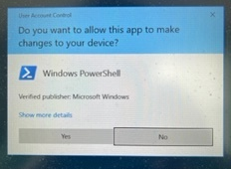
The “lab area” box will popup- click OK to access the PROD area.
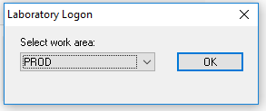
The SQ GUI Login screen requires 3 entries.
- User ID
- Sunquest Password
- Lab Location
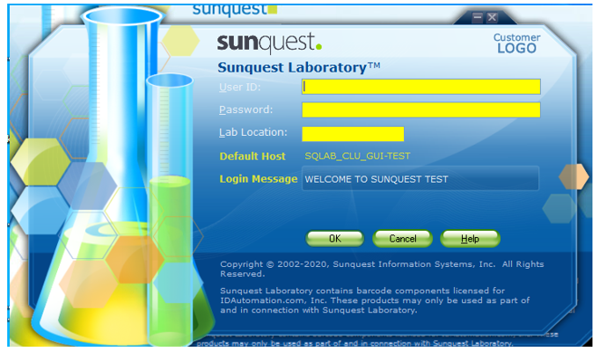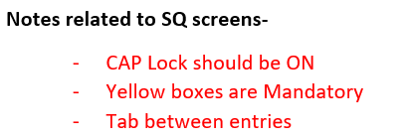

User ID: your partners log-on code
Password: Default password will be your partners log-on and you will be prompted for create a new password. HINT: You can make the password the same as your Partners password
Requirements- implemented to be in line with Partners password guidelines
- 8 to 15 characters
- At least one character must be an UPPER case letter (we recommend they all be in CAPS)
- At least one character must be a number
- Password will expire in 90 days
- The SQ password is not linked to any other password changes.
Lab Location: WDR

Processing Unreceived Specimens
Once the patient’s specimens have been collected the specimens must be received in the lab. This process is done using the Order Receipt/Modify (ORM) process.
Single click the General Laboratory Icon from the Sunquest
Click on Orders drop-down menu and click on Order Receipt/Modify (ORM)
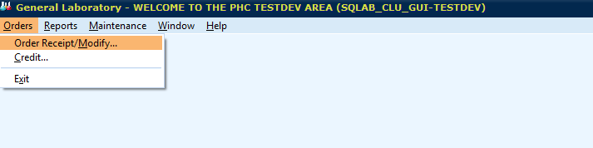

The Order Access screen will pop up-
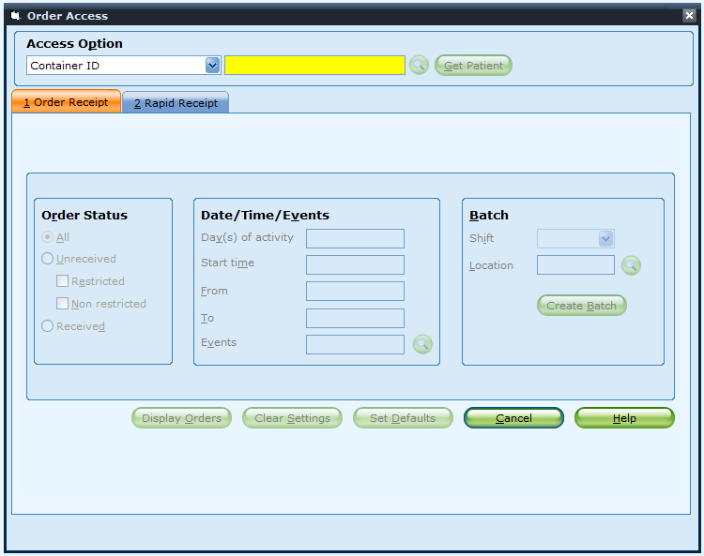
The default access for this screen is CONTAINER ID (CID)- that is the barcoded element on the specimen labels and can be scanned in at this prompt to bring up the Accession.
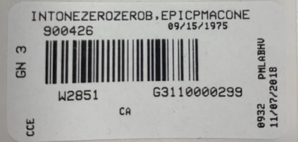
Another access option is the patient MEDICAL RECORD number. You can change the lookup by clicking the down arrow and selection
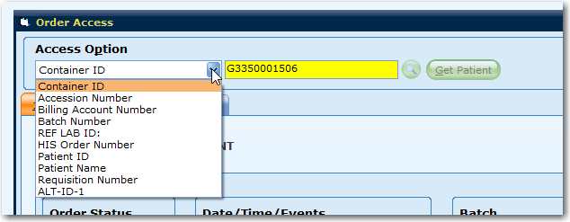
Either access option will bring up patient information
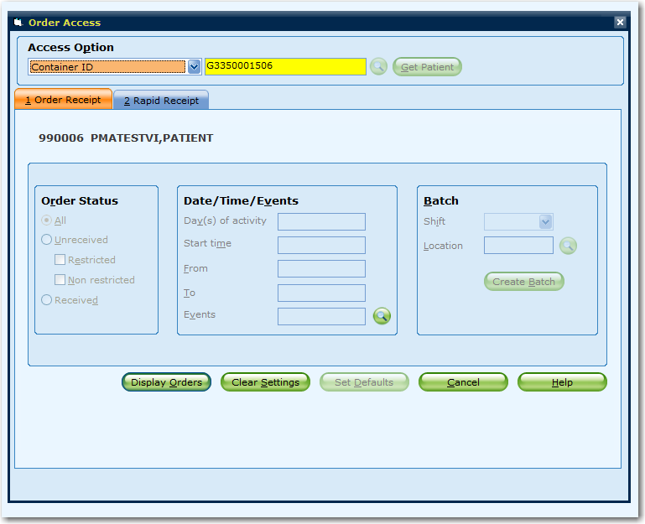
Verify that the information is correct and press the Display Orders button.
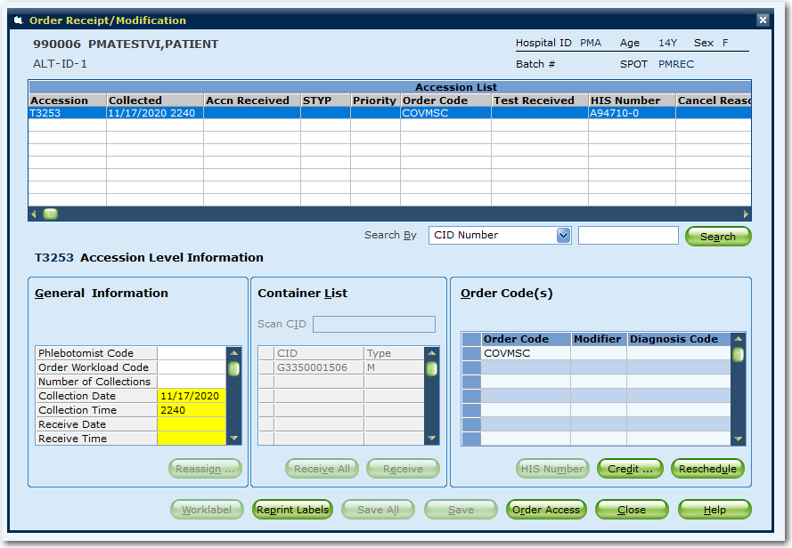

On the selected accession number, the General Information box will need to have mandatory fields (yellow) filled in.
HIT the TAB key 6-7 times and it will move through the General information section causing the Receive Date and time field to be auto-populated.
Once a collect time and receipt time has been entered, the system will activate the Container List and Order Code(s) windows.
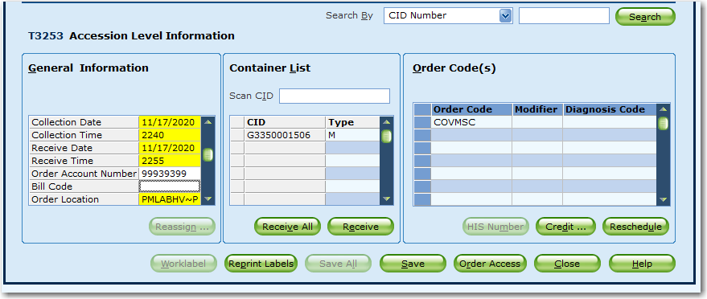

In the Container List, verify the CID on the tube matches the CID in the container list box.
(CID: container ID- long L number on the label) and click RECEIVE ALL button to mark the container with an X.
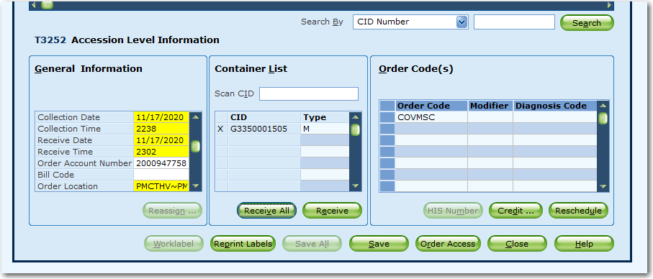
Click the SAVE button (ALT S) to save the order and make it active.
The screen is returned to the Order access screen and you can scan in the next ‘unreceived’ accession.

Specimen Tracking /Automated Resulting
This functionality is being used to:
- Facilitate the resulting of the Cytology specimen STATUS test. This tracking step allows the specimen to be qualified for an automated resulting process (created by BWH labs).
- It puts a tracking location timestamp on the specimen that can used to indicate that the specimen was delivered to the Cytology lab.
Click on the SMART (Specimen Management Routing and Tracking) icon from the SQ GUI Gateway
TRACKING a specimen to a SPOT
Select Tracking -> Specimen -> Tracking
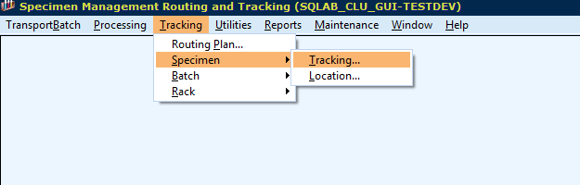
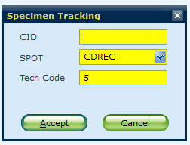
WDCYT

The Tracking SPOT needs to be set to WDCYT. Click the dropdown arrow and then start typing in the SPOT field until BWCYT is visible in the list. Click on it. Or simply type WDCYT in the Spot field.
It is CRITICAL to this process that this spot be changed before tracking. If that is not done, the automated process for adding the correct clinical order will NOT occur.

With the cursor in the CID field scan each barcode and hit the enter key to process the ACCEPT button.

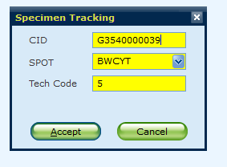
WDCYT
It may take 1- 4 minutes for the result to post in SQ.

PENDING LOGS - To be printed at the beginning end of each day

Log-on SQ1-Smarterm
Open APPLICATIONS from the START menu
Click on SQ1 - SmarTerm
The following question MIGHT appear- Hit Y to respond Yes.
(After responding yes, it is possible that the question will not appear again)
NOTE: Upper case is mandatory at this point, and you use the ENTER/Return key to move between prompts. The mouse and tab keys do not work in this Roll/Scroll application.

Live/Production Area

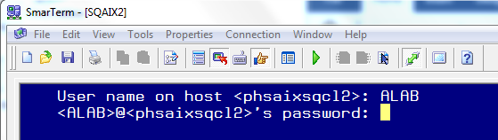

User name on host: ALAB and press Enter.
Password: SQALAB and press Enter.

At the device location prompt: (Another word for Lab Location) Enter your specific code from list below.
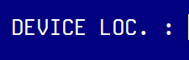 WDR

Type in YOUR access code (Partners ID) and Sunquest password and press ENTER

Access Code: same as your Partners network ID
Password: You may be prompted to set up a new password after logging in.

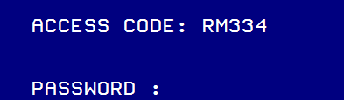

.
With a successful logon it should take you to the Function prompt
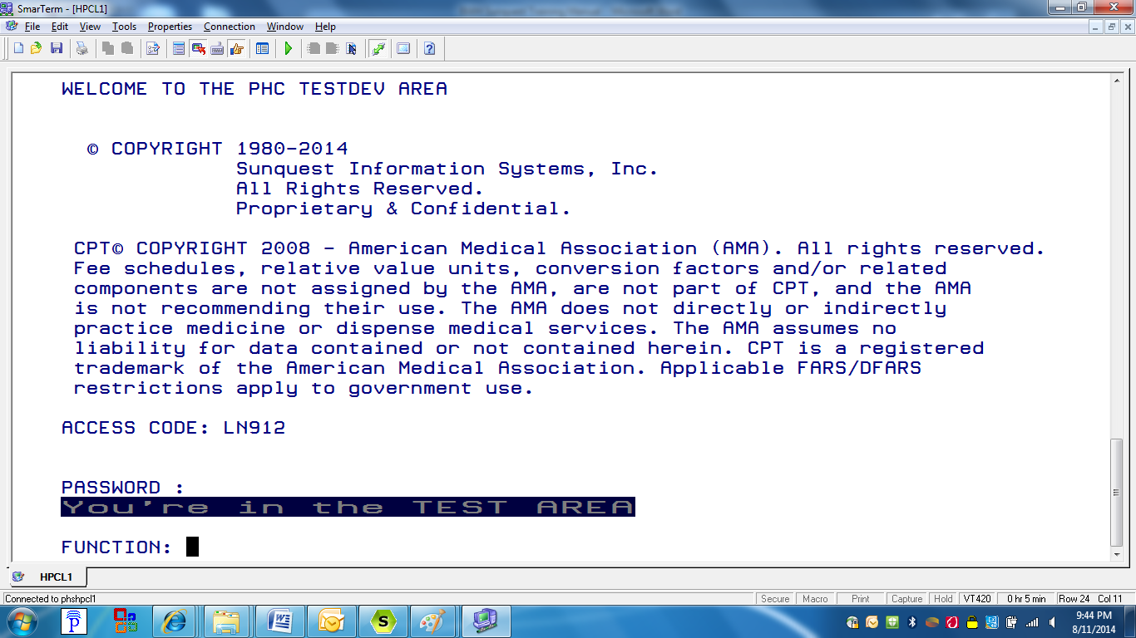

SQ1 Pending Logs

Pending log for RECEIVED orders/specimens
Open an SQ1 SmarTerm session
Function prompt: PL
Printer: Enter a Sunquest printer ID (note: enter 0 and the report will print to your screen)
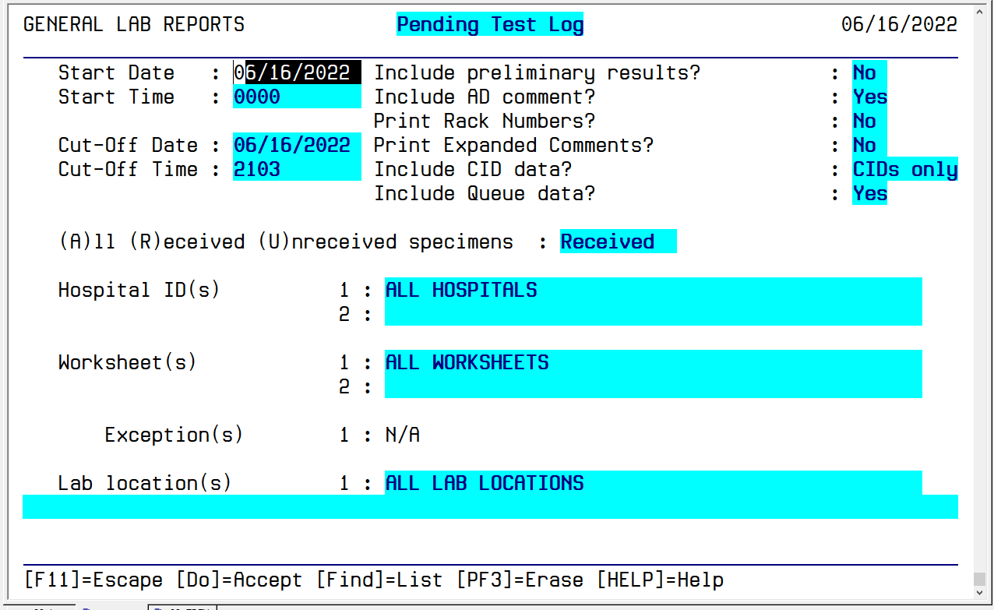
Use the Enter key to move from Field to Field. The up-arrow can take you to the previous entry.
To set the query parameters, determine the best values for the following parameters:
- Start Date: Receipt date (when it was processed in the clinical lab area) Will default in Current date
  - Recommend back dating a consistent number of days (catch all) by enter in the format T- x (x is the number of days)
- Start Time: Accept the default of 0000
- Cut-Off Date: Receipt date. Will default in Current date.
- Cut-Off Time: Receipt time. Defaults in ‘current time’.
  - Accepting this time would bring in Specimens received right up to the current minute.
  - Time is entered in Military time Format 0905 (9:05 am)
Enter through the next parameters until you are at the Hospital ID prompt.
- Hospital ID (s)
  - Enter the SQ mnemonic for your site: WDH
- Worksheet (s)
  - Enter the Site specific worksheet code: WDCYT
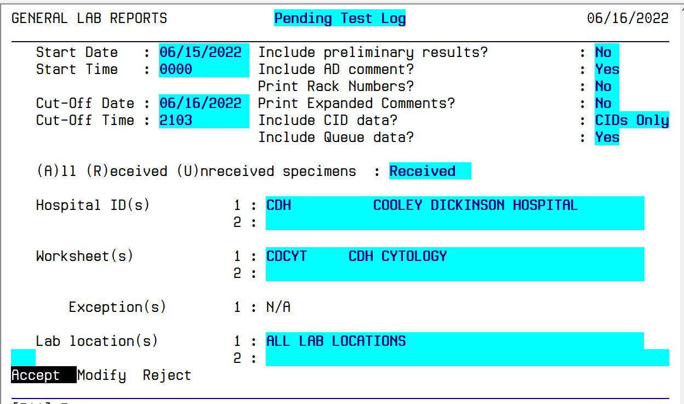
WDCYT WDH Cytology
WDH Wentworth Douglass Hospital
Enter past the Worksheet prompt until the Accept/Modify/Reject prompt appears with the ACCEPT prompt backlit. Hitting the enter key will accept the prompt that is highlighted. Use the left/right arrows to move between the other options. Hit Enter when the option you want is highlighted.
The printed output looks like this: 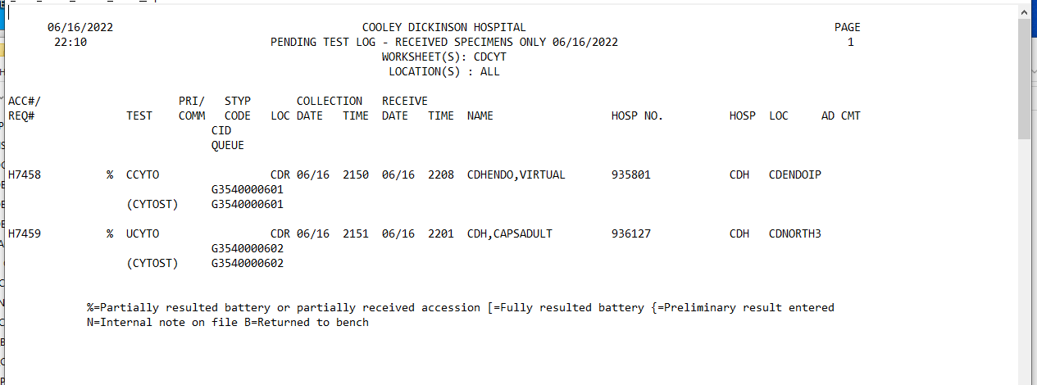

Pending log for UNRECEIVED orders/specimens-
- Could be orders that have been released to SQ but never collected. These will autocancel in a set number of days. The number of days has been determined by each site.
- Could be orders that are in Transit to the Clinical lab processing area.
- Could be shared specimen with clinical lab tests, where two labels were sent (one for CP, one for Cytology) but only one was “scanned” and received in the processing area.
- Use this log to identify potential missing specimens before they might be discarded by other sections of the lab.
The process is the same as calling a Received pending log EXCEPT at this entry field:
Enter U (Unreceived) and hit Enter to continue to the Hospital ID prompt. The query setup screen will look like this:
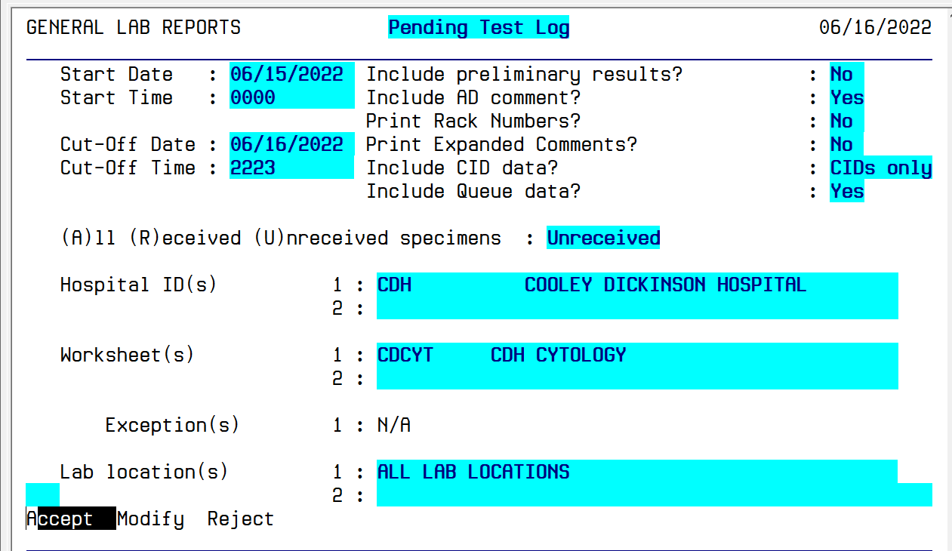
WDCYT WDH Cytology
WDH Wentworth Douglass Hospital
The printed output looks like this:
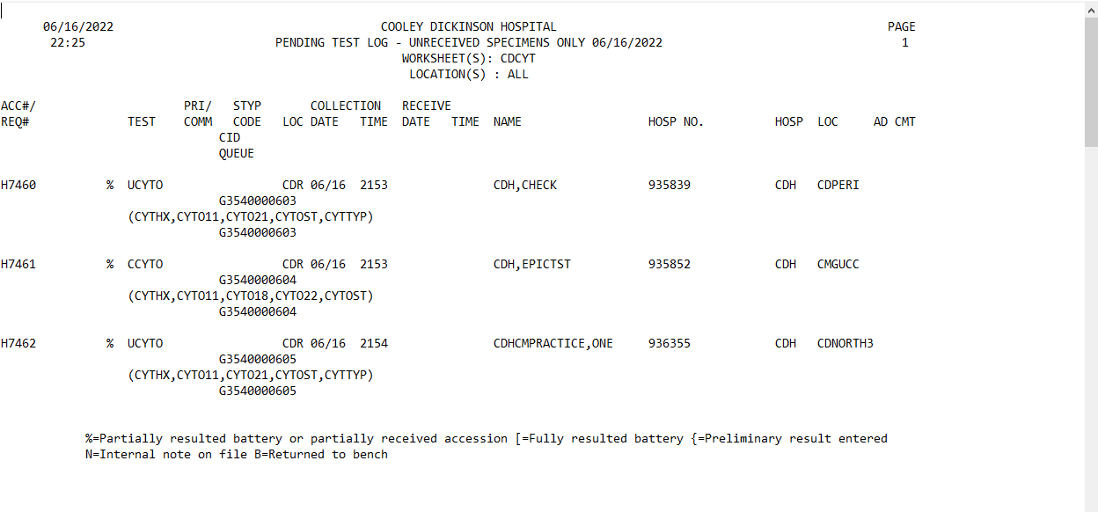

SQ Lab Inquiry-
Laboratory Inquiry Function
- View patient data
Single click the Laboratory Inquiry icon from the SQ
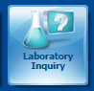
Lookup by: Patient ID (default) This is Sunquest term for MRN.
You have multiple ways to lookup by clicking the Lookup by drop-down arrow.
For this Cytology workflow, if you are printing from SQ, we recommend using Container ID as your Lookup mode. You can scan the Specimen container label which has the data element barcoded. This option will take you directly to the accession with the Cytology orders and you will not need to ‘work through’ any clinical lab accessions that could be present.
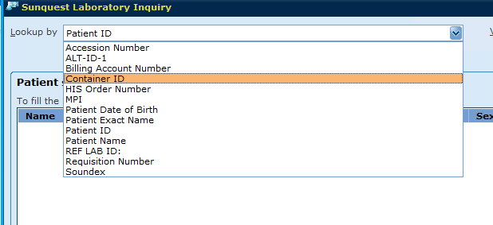

Enter the value to perform the lookup on in the Value field and then click the Search button.

The patient will display- Confirm the Patient identified with the name on the tube.
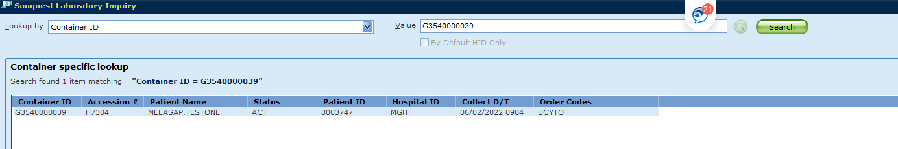

Select Get Results button at bottom of screen to view results.
Inquiry Data display
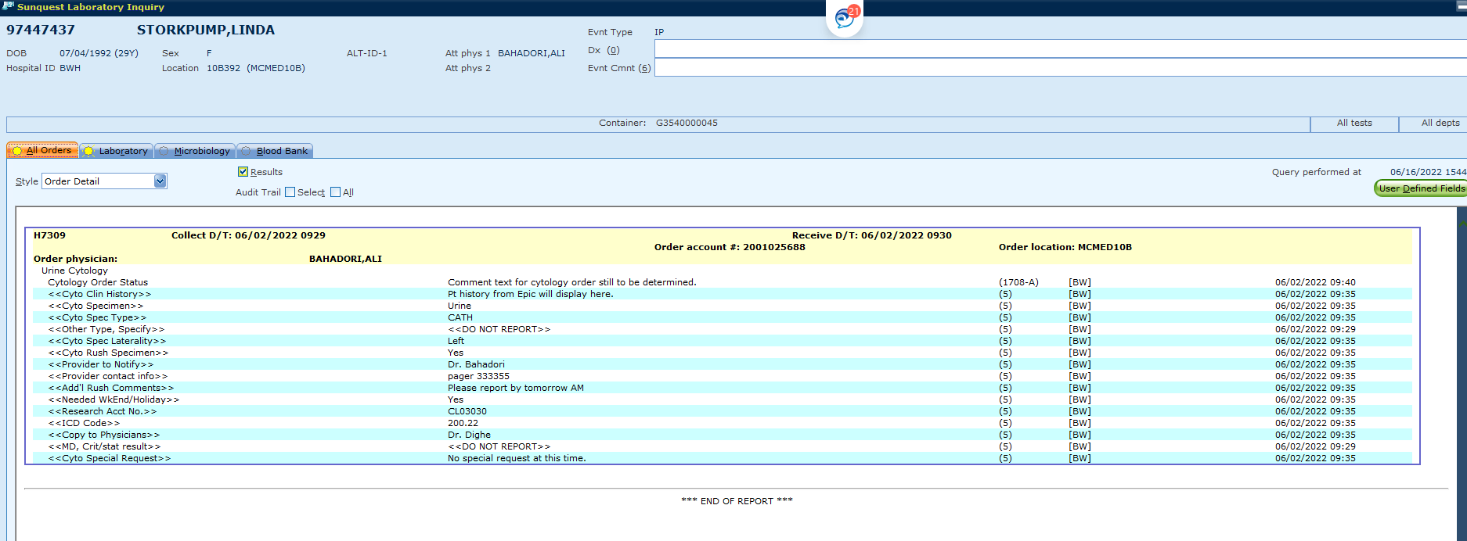

To look up another patient without starting over from the beginning, click on Query button and it will bring you back to the Search screen.
