DECANTING

CHEMISTRY RANDOM URINES (VMACR, VCRE, UPHOS etc.) and ARUP SENDOUTS

1. Go to **General Lab** to receive your specimen
2. Go to **SMART** and Select **Processing - Decant**
3. 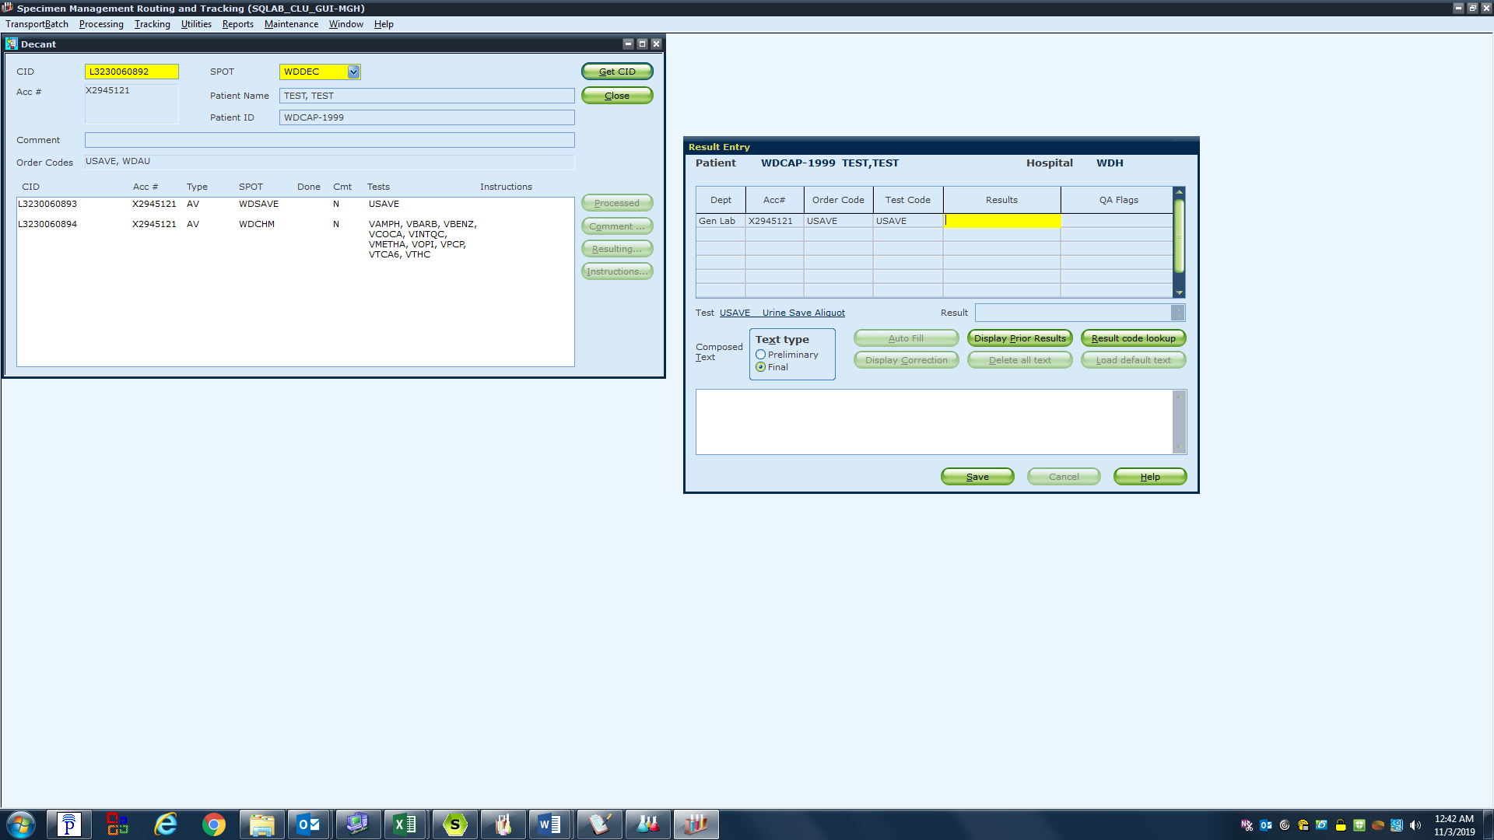Scan or type the CID and select WDDEC in the drop down for the spot. Select Get CID

Special instructions such as ARUP testing guidelines will appear here

1. Select **Processed** and your aliquot label will print.

(Select **Cancel** at the next pop up to ignore the rack processing prompt.)

**\*\*This label goes on the aliquot tube\*\***

URINE DRUG SCREEN (WDAUP, WDTOXP)

1. Follow the same process as above
2. DAU’s will pop up with a mandatory Result field; type in **DONE** and select SAVE. Your labels will now print.



These aliquot labels will both go on the yellow urine tubes

**If you are Decanting a WDUTOXP you will also receive a label that goes on the sendout aliquot tube**

24HR URINE PROCESSING

1. Go to **General Lab** to receive your specimen

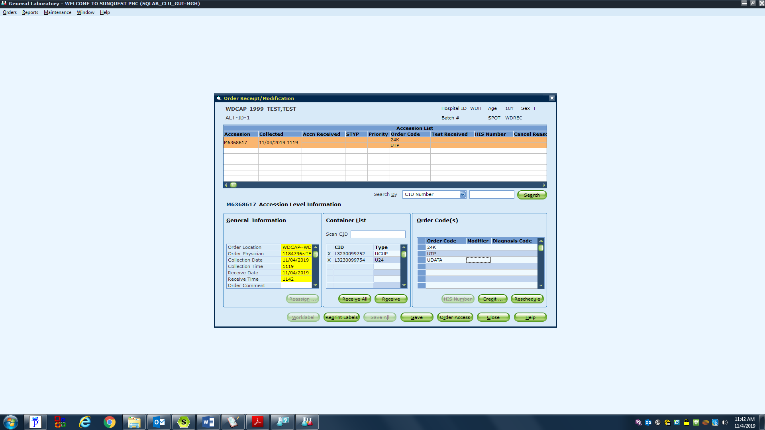

2. In the Order Codes box add **UDATA** to all 24hr. specimens. Select **Save**

3. Another box will pop up

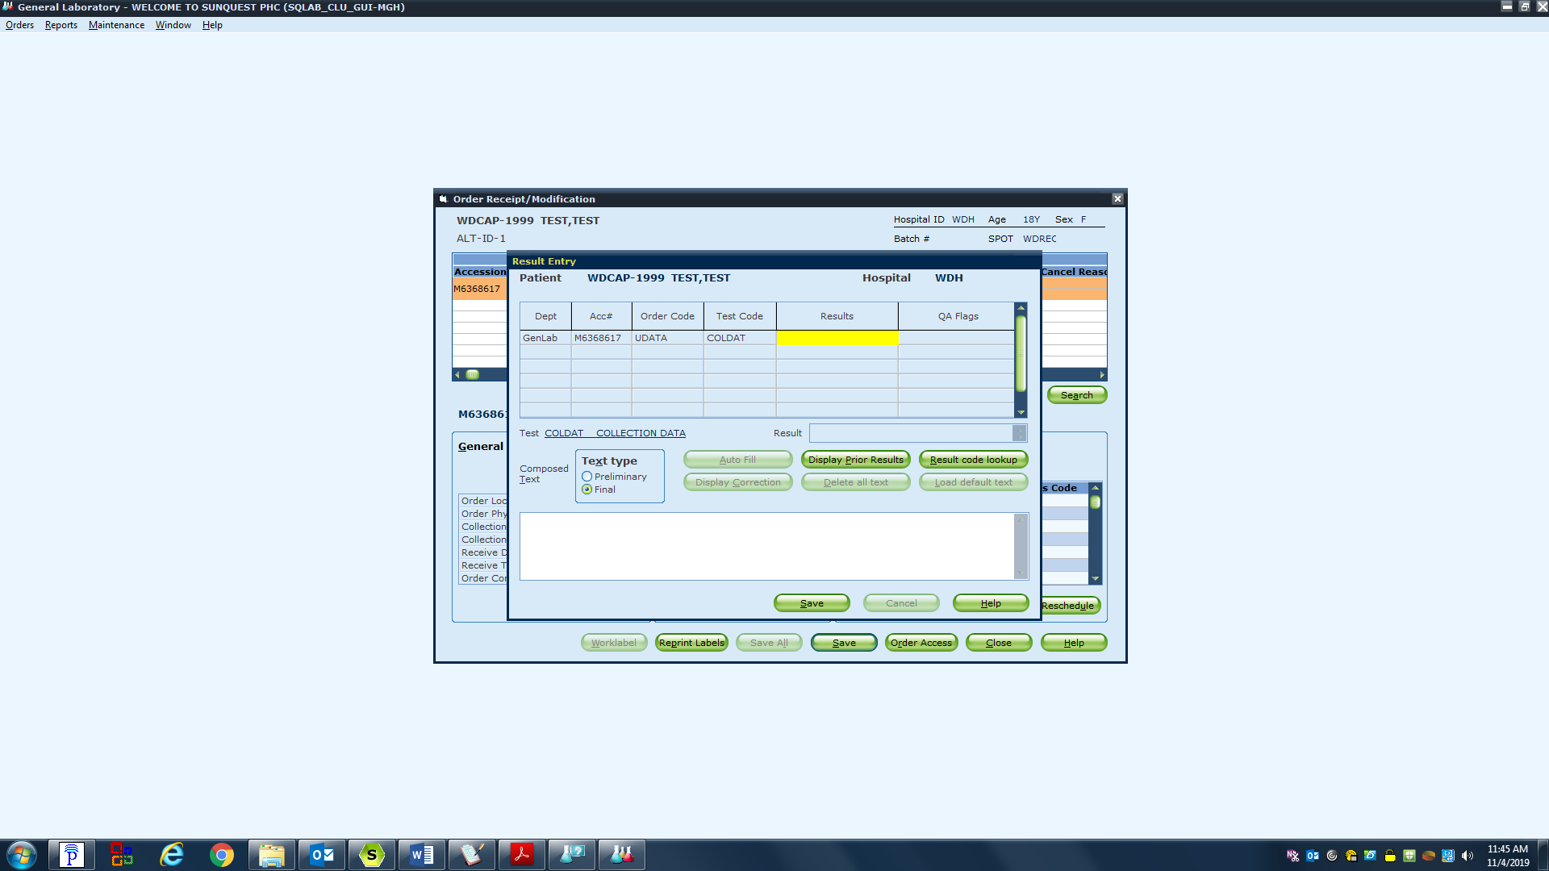

1. In the text field Enter**; ”date and time started” TO “date and time ended” .**
2. Select **SAVE**

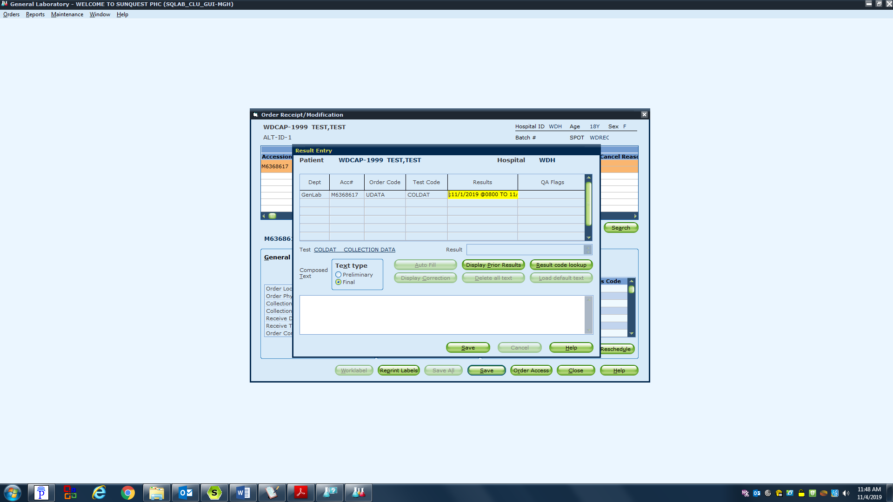

1. Go to **SMART** and Select **PROCESSING - DECANT**
2. Scan or type the **CID** and select **WDDEC** in the drop down for the spot. Select **Get CID**

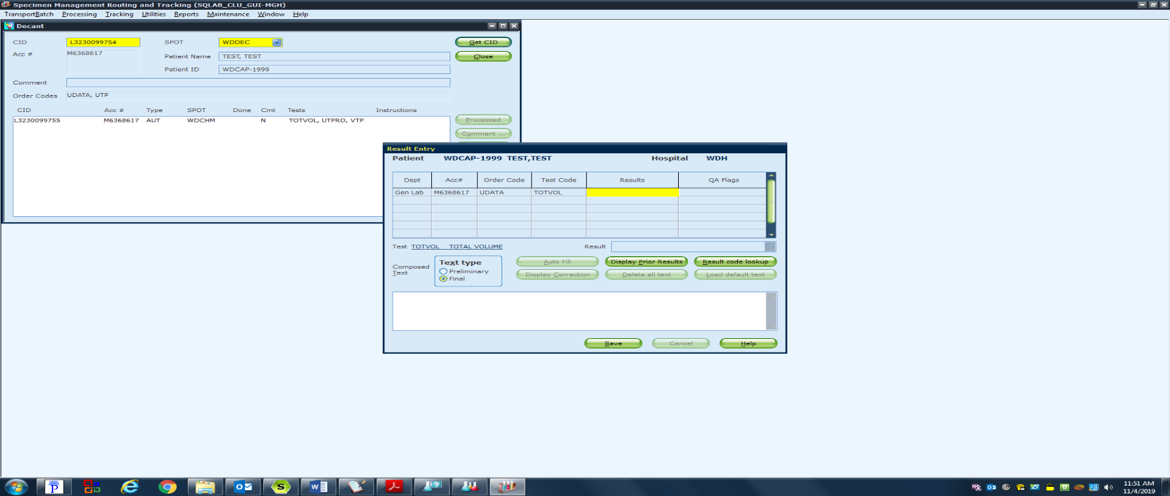Enter **Total Volume** in result field

Select **Save**

Select **Processed**

Labels will print that will be used for the aliquot tube

***IF YOU ARE ORDERING THE 24HOUR URINE TESTS YOU CAN ALSO ENTER THE UDATA IN ORDER ENTRY***